AI INTERVIEW COACH
Document 4 of 7
System Analysis and Design
Problem and objectives, use case model, requirements traceability, architecture, database design, data flow, UML diagrams, user interface design, technology stack, API documentation, testing and deployment strategy.
Item | Detail
Project | AI Interview Coach
Team | Team 147
Course / Track | AI Capstone Project -- Hybrid (Deep Learning / NLP + LLMs & RAG)
Document set | Project Documentation Package (7 documents)
Implementation baseline | GitHub repository Mennatullah-essam/ai-interview-coach, branch main, commit 491f8ae (24 October 2026)
Prepared | 24 October 2026
Status | Draft for academic review

Table of Contents
About This Document
Scope of This Document
4.1 Problem Statement and Objectives
4.1.1 Problem Statement
4.1.2 Objectives and Status
4.1.3 Design Decisions That Changed the Planned Scope
4.2 Use Case Model
4.2.1 Use Case Diagram
4.2.2 Use Case Summary
4.2.3 Descriptions of the Added Use Cases
4.3 Functional and Non-Functional Requirements
4.3.1 Functional Requirements Traceability
4.3.2 Non-Functional Requirements Traceability
4.4 Software Architecture
4.4.1 Architectural Style
4.4.2 Layers and Responsibilities
4.4.3 Hybrid Intelligence Design
4.4.4 Key Architectural Decisions
4.5 Database Design
4.5.1 Entity Relationship Diagram
4.5.2 Logical Schema
4.5.3 Physical Schema
4.6 Data Flow Diagrams
4.6.1 Context Diagram (Level 0)
4.6.2 Level 1 Diagram
4.7 Sequence Diagrams
4.7.1 Login and Session Refresh
4.7.2 Answer Submission, Evaluation and Follow-up
4.8 Activity Diagram
4.9 State Diagrams
4.10 Class Diagram
4.11 User Interface Design
4.11.1 Screens and Navigation
4.11.2 UI/UX Guidelines
4.12 Technology Stack
4.13 Component and Deployment Diagrams
4.14 API Documentation
4.14.1 Conventions
4.14.2 Endpoint Catalogue
4.14.3 Example: Create an Interview (E11)
4.14.4 Example: Evaluate an Answer (E16)
4.14.5 Error Codes
4.15 Testing and Validation Strategy
4.16 Deployment Strategy
4.16.1 Environments
4.16.2 Release Procedure (target)
Appendix A -- Consistency With Documents 1-3

About This Document
This document is Document 4 of the seven-document Team 147 package. Documents 1-3 (Project Planning and Management, Lecturer Review, Requirements Gathering) consolidate the nine original source documents and describe the project as planned. Documents 4-7 (System Analysis and Design, Implementation, Testing and Quality Assurance, Final Deliverables) describe the system as it was actually built, using the repository as the source of truth.
Implementation baseline: GitHub repository Mennatullah-essam/ai-interview-coach, branch main, commit 491f8ae (24 October 2026). Every statement about the system was checked against that code. Where the built system differs from Documents 1-3, the difference is stated and labelled rather than hidden. Status labels used throughout:
Label | Meaning
Implemented | Present in the code at the implementation baseline and exercised by automated tests or an observed end-to-end run.
Implemented (changed) | Implemented in a different form from Documents 1-3, following a recorded decision (API specification D1-D8 or a later milestone decision).
Partially implemented | Present, but narrower than the requirement, or available in the backend only.
Not implemented | Absent from the code at the baseline; the reason (decision, deferral or gap) is stated.
Confirmed / Proposed | As in Documents 1-3: stated in the sources as a decision, or as a proposal not yet confirmed.
Recommendation (review) | Added during this documentation review; not present in any earlier document.
To Be Confirmed | Required information (a date, an owner, a value) is missing or conflicting.

Scope of This Document
Document 4 covers the System Analysis and Design phase of the project documentation guideline: problem statement and objectives (4.1), use case diagram (4.2), functional and non-functional requirements (4.3), software architecture (4.4), ER diagram and logical/physical schema (4.5), data flow diagrams (4.6), sequence, activity, state and class diagrams (4.7-4.10), wireframes and UI/UX guidelines (4.11), technology stack (4.12), component and deployment diagrams (4.13), API documentation (4.14), testing and validation (4.15) and deployment strategy (4.16).
Requirements are referenced by their Document 3 identifiers and are not restated. Implementation details (code standards, version control, CI/CD, README) are in Document 5; test evidence is in Document 6.

4.1 Problem Statement and Objectives

4.1.1 Problem Statement
Candidates usually prepare for interviews with generic question lists, occasional mock interviews or self-assessment, so they rarely get specific, repeatable and objective feedback on their own answers (Document 1, section 1.1.2). AI Interview Coach addresses this with a web application that plans an interview from the candidate's CV and target role, evaluates each typed answer against a curated rubric, explains every score, and turns the results into an improvement plan that is tracked across interviews.
The system was designed under four constraints that shaped every later decision: (1) no paid or external AI service is required, and no CV text leaves the machine by default (decision D4); (2) feedback must be explainable and must not claim to measure psychological confidence (D5); (3) the application must run locally on a student laptop with free software (D1, D2); (4) private CV data must be isolated per user from the first public deployment (D3, D7).

4.1.2 Objectives and Status
Objectives O1-O6 are those of the Project Proposal (Document 1, section 1.1.3). The status column reports what the implementation baseline achieves.
Table 4.1 -- Project objectives and implementation status
ID | Objective | Status | Evidence and remaining work
O1 | End-to-end working platform (CV upload, interview session, feedback dashboard) | Partially implemented | Complete flow works locally and in a production-style single-origin build (34/34 browser checks). Not yet deployed publicly, so "in a deployed environment" is open.
O2 | Answer-evaluation model scoring answers by semantic similarity to ideal responses | Implemented (changed) | Rubric-based scorer with similarity as supporting evidence. Agreement with developer-labelled expectations 93.2% (development set) and 70.4% (held-out). No human-rated benchmark yet, so the Spearman target is not measured.
O3 | Personalized questions and ideal answers from CV and role using an LLM | Implemented (changed) | Questions are selected from the curated bank and personalised by role, job description and confirmed profile (required-skill coverage 0.856). LLM generation deferred (D4); an optional, off-by-default LLM can only propose follow-ups and bounded reviews.
O4 | Actionable feedback for every answer | Implemented | 100% of evaluated answers receive strengths, weaknesses, suggestions and concept evidence; evaluation median 3 ms (lexical engine).
O5 | Scalable, monitored cloud deployment on AWS | Not implemented | AWS deferred (D8). A container image and an Azure Container Apps guide are prepared; monitoring not implemented.
O6 | Complete documentation and final demonstration | Partially implemented | Documents 1-7, READMEs and API specification exist; presentation material in Document 7. Demonstration date To Be Confirmed.

4.1.3 Design Decisions That Changed the Planned Scope
The API specification (API_SPECIFICATION.md, section 1.6) recorded eight working decisions before implementation. They explain most differences between Documents 1-3 (as planned) and Documents 4-7 (as built).
Table 4.2 -- Working decisions D1-D8 and their effect
ID | Decision | Effect on the built system
D1 | Develop and test locally first; keep the existing React/Vite frontend; FastAPI backend. | Frontend kept at the repository root; backend in backend/. Changes to the frontend were made through the API client.
D2 | PostgreSQL locally; no paid database; portable to a managed service later. | PostgreSQL 16+ with Alembic; resolves open decision C-04 (Document 1) in favour of PostgreSQL. pgvector not used.
D3 | Authentication deferred in the first MVP, required before public deployment. | Superseded in implementation milestone IM-3: full authentication was built before any deployment.
D4 | No OpenAI, Bedrock or other paid API in the MVP; curated bank; rule-based feedback. | Question selection instead of generation; RAG reduced to retrieval and ranking. IM-5 added an optional, local-first LLM that is off by default.
D5 | Local Sentence Transformers if supported, combined with explicit criteria; no "confidence" claim. | Lexical engine by default, all-MiniLM-L6-v2 optional; BERT/DistilBERT not used; the figure is called a score.
D6 | Text answers only; Whisper deferred. | FR-035 to FR-038 not implemented; resolves open decision C-03 for this release.
D7 | Free libraries for CV parsing; private file storage. | pypdf and standard-library DOCX parsing; storage abstraction (local folder now, S3 or blob storage later).
D8 | AWS availability unconfirmed; create no resources; deployment later. | No AWS resources. A cost-free container deployment path (Azure for Students) was prepared instead.

4.2 Use Case Model

4.2.1 Use Case Diagram
Figure 4.1 shows the actors and use cases of the implemented system. UC-01 to UC-05 keep their identifiers from Document 3 (section 3.2.2). UC-06 to UC-09 were added because the implementation introduced user-visible functions that Document 3 did not describe. UC-04 is shown outside the system boundary because monitoring is not implemented.
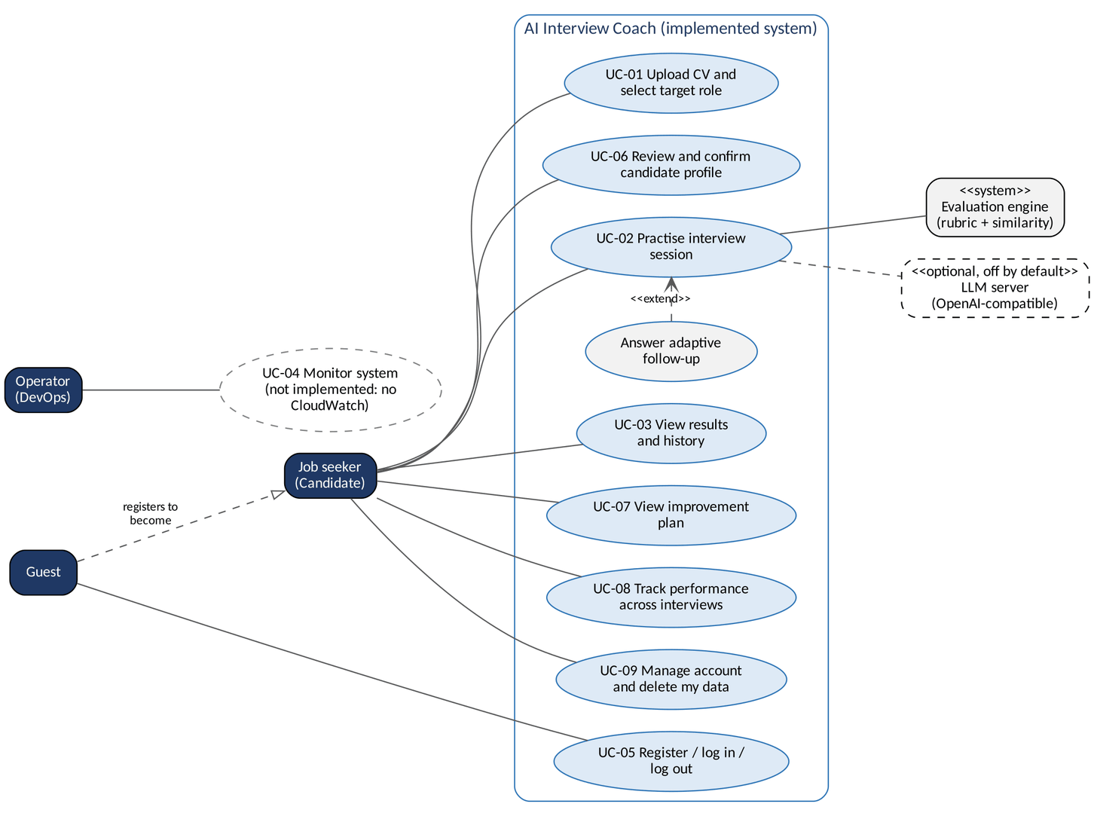
Figure 4.1 -- Use case diagram of the implemented system

4.2.2 Use Case Summary
Table 4.3 -- Use cases, traceability and status
ID | Use case | Actor | Requirements | Status
UC-01 | Upload CV and select target role | Job seeker | FR-007 to FR-017 | Implemented
UC-02 | Practise interview session (incl. adaptive follow-ups) | Job seeker; evaluation engine; optional LLM | FR-018 to FR-060 | Partially implemented
UC-03 | View results dashboard and history | Job seeker | FR-061 to FR-070 | Implemented
UC-04 | Monitor system performance | Operator (DevOps) | FR-071 to FR-073 | Not implemented
UC-05 | Register, log in, log out | Guest / Job seeker | FR-001 to FR-006 | Implemented
UC-06 | Review and confirm candidate profile (added) | Job seeker | FR-012 (changed); new | Implemented
UC-07 | View improvement plan (added) | Job seeker | FR-050, FR-052 | Implemented
UC-08 | Track performance across interviews (added) | Job seeker | FR-070 | Implemented
UC-09 | Manage account and delete my data (added) | Job seeker | FR-006, FR-013, FR-069 | Partially implemented

UC-02 is partially implemented only because skip (FR-027) and voice answers (FR-035 to FR-038) are absent; the main flow works. UC-09 is partial because the account itself cannot be deleted.

4.2.3 Descriptions of the Added Use Cases
UC-01 to UC-05 are described in Document 3, section 3.2.3; their implemented flows match those descriptions apart from the differences in Table 4.4.
UC-06 -- Review and confirm candidate profile
Element | Description
Actor / precondition | Job seeker with a parsed CV.
Main flow | 1. After upload the system builds a draft profile: technical and soft skills, experience, education, projects, achievements, expertise areas, estimated years and level, target role.  2. Each item is tagged extracted (with the CV line as evidence), inferred (with the rule) or user.  3. The user corrects, removes or adds items and confirms.  4. The server recomputes provenance and stores the confirmed profile.
Alternative flows | Unreadable layout or missing sections: warnings are shown and nothing is invented. Rebuild: re-extracts from the newest CV, keeps user-added items, returns to draft.
Outcome | Only a confirmed profile personalises interviews (project questions, skill-gap checks).

UC-07 -- View improvement plan
Element | Description
Actor / precondition | Job seeker with at least one completed interview.
Main flow | 1. On completion the system stores a plan for that interview.  2. The user opens it from Results, Performance or the navigation.  3. The plan shows strengths, gaps (two or more weak answers), items needing more evidence, a competency table (CV versus interviews), practice questions, exercises, official resources and up to five next steps, with progress against the previous plan.
Alternative flows | No completed interview: PLAN_NOT_FOUND, and the page invites the user to start one.
Outcome | A prioritised, evidence-based practice plan.

UC-08 -- Track performance; UC-09 -- Manage account and delete data
Use case | Main flow and outcome
UC-08 | The Dashboard and Performance pages show the average score, completed interviews, strongest and weakest areas, a skill snapshot and the score trend, computed only from completed interviews of the signed-in user.
UC-09 | On Profile and settings the user changes name or email (unique) and can delete all practice data after a confirmation dialog. CVs, files, profile, interviews and plans are removed; other users are never affected (test test_clearing_my_data_never_touches_other_users).

Table 4.4 -- Differences between Document 3 use case flows and the implementation
Use case | Document 3 | Implemented
UC-01 | User may preview extracted text. | User reviews structured profile items with evidence (UC-06).
UC-02 step 1 | Questions generated by OpenAI / Bedrock. | Questions selected and ranked from the curated bank, with a reason shown for each.
UC-02 step 5 | Sentence Transformers / BERT / DistilBERT compute a confidence score. | Rubric scorer with six explained dimensions; similarity from a lexical engine or local Sentence Transformers.
UC-02 step 6 | GenAI produces suggestions, ideal answer and follow-up. | Rule templates produce suggestions; curated reference answer; follow-ups from the interview agent (adaptive mode only).
UC-02 alternatives | Skip a question; end early with partial results; voice answer. | Not available; "Exit" abandons the interview.
UC-05 | Repeated failures trigger a temporary block; forgotten password flow. | Per-IP rate limit; no password reset.

4.3 Functional and Non-Functional Requirements
The requirements themselves are specified in Document 3 (FR-001 to FR-073, NFR-001 to NFR-073) and are not repeated. This section traces each of them to the implementation so that the requirement set and the built system stay consistent. Document 3 identifiers are kept unchanged.

4.3.1 Functional Requirements Traceability
Summary: 45 Implemented, 12 Implemented (changed), 9 Partially implemented, 7 Not implemented (of 73).
Table 4.5 -- Functional requirements: status and implementation
ID | Requirement | Status | Implementation / reason
FR-001 | User registration | Implemented | POST /auth/register (E01); Sign-up page.
FR-002 | Unique email enforcement | Implemented | Case-insensitive; 409 EMAIL_ALREADY_REGISTERED; database CHECK keeps emails lower-case.
FR-003 | User login | Implemented | POST /auth/login (E02); every query is scoped to the signed-in user.
FR-004 | User logout | Implemented | POST /auth/logout (E04) revokes the refresh token and clears the cookie; the in-memory access token is discarded.
FR-005 | Password reset | Not implemented | No email service in the MVP (backend README section 12).
FR-006 | Account deletion | Partially implemented | DELETE /users/me/data (E24) deletes CVs, files, profile, interviews and plans; the account itself is kept.
FR-007 | CV upload | Implemented | POST /cvs (E07), drag-and-drop upload page.
FR-008 | CV file validation | Implemented | PDF/DOCX only, checked by content (magic bytes) and size (5 MB, enforced before reading).
FR-009 | CV text extraction | Implemented | pypdf for PDF, standard-library XML parsing for DOCX.
FR-010 | CV processing status | Partially implemented | Status stored (uploaded, parsed, failed); the UI shows uploading/processing states. No separate polling screen.
FR-011 | CV failure notification | Implemented | CV_UNREADABLE (422) for empty, encrypted, image-only or corrupt files; the user can upload another file.
FR-012 | Extracted text preview | Implemented (changed) | Instead of raw text, the Profile review page shows every extracted item with the CV line it came from.
FR-013 | CV replacement and deletion | Implemented | Replace and Remove buttons; DELETE /cvs/{id} (E10) also deletes the file.
FR-014 | CV reuse | Implemented | Interviews reference the stored CV (cv_id); no re-upload needed.
FR-015 | Job role list | Implemented | 7 preset roles (app/data/roles.json) plus a free-text role.
FR-016 | Job role selection | Implemented | target_role required (3-100 characters) when creating an interview.
FR-017 | Optional job description | Implemented | Up to 5,000 characters; skills found in it influence question ranking.
FR-018 | Personalized question generation | Implemented (changed) | Questions are selected and ranked from the curated bank, and skill/project templates are filled from the CV and confirmed profile. They are not generated by an LLM (decision D4).
FR-019 | Question count | Implemented (changed) | 5, 10 or 15 questions (Document 3: 5-10, default 5). Adaptive interviews may add 2/3/4 follow-ups.
FR-020 | Question categories | Implemented | Interview type technical, behavioral or mixed; mixed interviews combine both.
FR-021 | Question bank grounding | Implemented | 71 curated questions with reference answers, key points and misconceptions.
FR-022 | Duplicate question prevention | Implemented | No duplicates or near-duplicates (similarity >= 0.8 skipped); recently asked questions are down-ranked.
FR-023 | Question persistence | Implemented | Questions are stored with the session, including a hidden snapshot of the reference answer.
FR-024 | Session creation | Implemented | Requires a parsed CV (CV_REQUIRED) and a role.
FR-025 | Sequential question presentation | Implemented | One question at a time in stored order; follow-ups are inserted right after their parent.
FR-026 | Progress indicator | Implemented | "Question k of n" with a progress bar.
FR-027 | Skip question | Not implemented | Every question must be answered before an interview can be completed (INTERVIEW_INCOMPLETE).
FR-028 | Session resume | Partially implemented | Backend supports it (GET /interviews/{id} returns progress and current position; tested). The frontend does not yet resume after a page reload.
FR-029 | Session completion | Implemented | POST /interviews/{id}/complete (E14) aggregates scores and returns the results.
FR-030 | End session early | Implemented (changed) | "Exit" abandons the interview (POST /abandon, E13); abandoned interviews are excluded from history and statistics instead of producing partial results.
FR-031 | Text answer submission | Implemented | PUT .../answer (E15).
FR-032 | Answer length limits | Implemented (changed) | 30-1,500 characters (Document 3: not empty, at most 2,000), with specific error messages.
FR-033 | Answer review before submission | Implemented | Answers can be edited and re-saved until they are evaluated; then they are locked.
FR-034 | Answer persistence | Implemented | One answer per question (unique constraint), linked to user, session and question.
FR-035 | Spoken answer input | Not implemented | Deferred (decision D6: text only). Open decision C-03 in Document 1.
FR-036 | Speech transcription (Whisper) | Not implemented | Deferred (D6).
FR-037 | Transcript review | Not implemented | Deferred (D6).
FR-038 | Audio input error handling | Not implemented | Deferred (D6).
FR-039 | Answer evaluation | Implemented (changed) | Six-dimension rubric (relevance, key concepts, technical accuracy, structure, evidence, communication) plus lexical or local Sentence-Transformers similarity. BERT/DistilBERT not used (D5).
FR-040 | Reference answer source | Implemented | From the curated question bank (the GenAI source is deferred, D4).
FR-041 | Per-answer evaluation result | Implemented | POST .../evaluation (E16) returns score, strengths, weaknesses, suggestions, evidence.
FR-042 | Non-substantive answer handling | Implemented (changed) | Answers under 30 characters are rejected; off-topic answers are detected and relevance is capped at 35; very brief answers are reported as "insufficient evidence".
FR-043 | Semantic similarity computation | Implemented | Cosine similarity (lexical concept vectors by default; local embeddings when SIMILARITY_BACKEND=sbert). Used as supporting evidence only.
FR-044 | Confidence score generation | Implemented (changed) | 0-100 score per answer, called score, not confidence: the system does not measure psychological confidence (D5).
FR-045 | Score band label | Implemented (changed) | Three labels in the UI: Excellent (>= 88), Strong (>= 78), Needs Improvement (Document 3 proposed four).
FR-046 | Overall session score | Implemented | Mean of the scores of all questions in the interview, including follow-ups.
FR-047 | Scoring consistency | Implemented | Deterministic scoring (test test_same_input_gives_identical_result).
FR-048 | Per-answer strengths | Implemented | One to three strengths for every answer (a mild strength is always given).
FR-049 | Per-answer weaknesses | Implemented | One to three weaknesses tied to the weakest dimensions and missing concepts.
FR-050 | Session-level strengths and weaknesses | Implemented | Results page and improvement plan.
FR-051 | Per-answer improvement suggestions | Implemented | Suggestions list and a main tip for every answer.
FR-052 | Session-level recommendations | Implemented | Three recommendations per interview plus a stored improvement plan.
FR-053 | Feedback traceability | Implemented | Results list each question with its answer, score and feedback.
FR-054 | Ideal answer generation | Implemented (changed) | A curated reference answer and an answer outline (rubric points) are shown; they are not generated per CV (D4).
FR-055 | Ideal answer reveal | Implemented | Reference answers are never returned before the question is evaluated (test test_questions_never_reveal_reference_answers).
FR-056 | AI-generated content label | Partially implemented | Every evaluation states it is an automated estimate and shows its source (Rule-based or hybrid). Nothing is AI-generated by default, so no generated-content label exists.
FR-057 | Follow-up question generation | Implemented (changed) | Adaptive interviews: a rule-based agent (optionally an LLM proposal, always policy-checked) decides clarify / request example / probe concept / deepen.
FR-058 | Follow-up question response | Partially implemented | Follow-ups are answered like any question; there is no "decline" button.
FR-059 | Follow-up evaluation | Implemented | Same scorer as main questions.
FR-060 | Follow-up limit | Implemented | At most one per main question, none on a follow-up, 2/3/4 per interview, at most 2 per competency.
FR-061 | Session results summary | Implemented | Overall score, role, type, date and breakdown.
FR-062 | Per-question breakdown | Implemented | Question-by-question list with a detail dialog.
FR-063 | Score visualization | Implemented | Score ring, dimension bars and a score-trend chart.
FR-064 | Strengths and weaknesses display | Implemented | Separate Strengths, Areas for improvement and Recommendations sections.
FR-065 | Answer comparison view | Partially implemented | The reference answer is shown under the candidate's feedback ("View a stronger answer"), not side by side.
FR-066 | Results persistence | Implemented (changed) | PostgreSQL (local, portable to any managed PostgreSQL). AWS RDS not used (D2, D8).
FR-067 | Session history list | Implemented | GET /interviews (E19), newest first, type filter.
FR-068 | Past session review | Implemented | GET /interviews/{id}/results (E18).
FR-069 | Session deletion | Partially implemented | Only all practice data can be deleted at once (E24); single-session deletion is not available.
FR-070 | Score trend display | Implemented | GET /performance/summary (E21) trend chart on Dashboard/Performance.
FR-071 | Application logging (CloudWatch) | Partially implemented | Standard Python logging with request IDs; no CloudWatch (D8).
FR-072 | Performance metrics | Not implemented | No metrics export (D8). Benchmark script measures scoring latency offline.
FR-073 | AI component failure logging | Partially implemented | CV-extraction and LLM failures are logged with their type (never content); speech-to-text does not exist.

4.3.2 Non-Functional Requirements Traceability
Non-functional requirements are grouped as in Document 3. Where several neighbouring requirements share one status they are listed as a range. "Not measured" means the code supports the requirement but no measurement against the target has been made yet; Document 6 lists the open measurements.
Table 4.6 (3.4.1 Performance)
ID | Requirement | Status | Evidence / note
NFR-001..002 | API and page response times | Not measured | No load test yet. Light endpoints are simple indexed queries.
NFR-003 | CV processing time | Not measured | Extraction is synchronous and in-process; size and page count (30) are capped.
NFR-004..006 | Question set, evaluation and follow-up time | Met | Lexical engine benchmark: planning median 6.85 ms, evaluation median 3.0 ms / p95 8.5 ms (single process, developer machine).
NFR-007 | Transcription time | Not applicable | No speech input (D6).
NFR-008..010 | Concurrency, DB query time, resource use | Not measured | No load test; memory after start-up about 55 MB with the lexical engine.
NFR-011 | Models loaded once | Implemented | Embedding model and indexes are created once per process and cached (vectors also on disk).
NFR-012 | Scale without redesign | Implemented | Stateless API (state in PostgreSQL) packaged as one container; except the in-memory rate limiter.

Table 4.6 (3.4.2 Security and privacy)
ID | Requirement | Status | Evidence / note
NFR-013 | Authentication on protected endpoints | Implemented | Bearer JWT; test test_protected_endpoints_require_authentication.
NFR-014 | Per-user authorization | Implemented | Foreign resources return 404 (not 403) so ids cannot be probed; test_isolation.py.
NFR-015 | Salted adaptive password hashing | Implemented | scrypt (n = 2^17, OWASP minimum) from the Python standard library.
NFR-016 | Password policy | Partially implemented | Minimum 8 characters; no letters-and-digits rule.
NFR-017 | Session expiry | Implemented | Access token 15 minutes; refresh cookie 7 days, rotated on every use, revoked on logout.
NFR-018 | Failed-login limiting | Partially implemented | 10 login/sign-up attempts per IP per minute (429), not a per-account lockout.
NFR-019 | HTTPS | Not verified | Depends on the host; production refuses insecure cookie settings.
NFR-020..022 | Encryption at rest, private CV files, private DB | Partially implemented | CV files under random names in a private, never-served folder; encryption at rest depends on the host.
NFR-023..024 | Server-side validation, content-based file check | Implemented | Strict schemas reject unknown fields; magic-byte check, zip-bomb cap, encrypted PDFs rejected.
NFR-025 | SQL injection, XSS, CSRF | Implemented | ORM parameters; React escaping; SameSite=Strict cookie + required X-AIC-Client header on refresh/logout.
NFR-026 | Rate limiting | Partially implemented | Login and sign-up only; in memory per process.
NFR-027 | Permanent deletion | Partially implemented | Data deletion removes rows and files; account deletion not offered.
NFR-028 | No audio retention | Not applicable | No audio.
NFR-029 | Secrets out of code | Implemented | .env git-ignored, SecretStr settings, .env.example with placeholders only.
NFR-030..031 | GenAI calls backend-only; contact details removed | Implemented | LLM gateway runs on the server, is off by default and strips emails, phone numbers and links; CV text is never sent.
NFR-032 | No secrets or content in logs | Implemented | Logs never contain passwords, tokens, CV text or answers.
NFR-033..034 | CORS restriction, generic errors | Implemented | Configured origins only; one error envelope with request id, no stack traces.
NFR-035 | Least-privilege cloud permissions | Not applicable | No cloud deployment yet.
NFR-036 | Third-party processing notice | Not applicable | No third-party AI by default. If a hosted LLM is enabled (LLM_ALLOW_EXTERNAL=true), a notice must be added first.

Table 4.6 (3.4.3 Usability and accessibility)
ID | Requirement | Status | Evidence / note
NFR-037..038 | Navigation, position in workflow | Implemented | Top navigation and mobile tab bar; session progress bar. No global CV-Role-Interview-Results stepper.
NFR-039..041 | Upload limits shown, status and loading indicators | Implemented | "PDF, DOCX - Max 5 MB" shown before upload; skeletons and a thinking indicator during evaluation.
NFR-042..046 | Session layout, consistent feedback, number + label, labelled charts, plain errors | Implemented | Scores always shown as numbers with labels; readable error messages from api.js.
NFR-047 | Responsive UI | Implemented | Checked at 390 px width without horizontal scrolling (end-to-end test).
NFR-048 | Basic accessibility | Implemented | Labelled controls, keyboard operation, focus trap in dialogs, skip link, visible focus, aria-live messages, reduced motion.
NFR-049 | Consistent components | Implemented | 32 shared components and one set of design tokens.
NFR-050 | First-session success test (5 users) | Not measured | No user study yet.
NFR-051 | Confirmation before destructive actions | Implemented | Confirmation dialog for deleting practice data and exiting an interview.
NFR-052 | Microphone permission message | Not applicable | No voice input.

Table 4.6 (3.4.4 Reliability)
ID | Requirement | Status | Evidence / note
NFR-053 | Availability during evaluation | Not verified | Not deployed yet.
NFR-054..056 | GenAI outage handling and fallbacks | Implemented | The bank and rule-based scoring never depend on an LLM; LLM timeout 12 s, 1 retry, circuit breaker after 3 failures (Document 3 proposed 30 s).
NFR-057..058 | No partial CV records; answer kept if evaluation fails | Implemented | Answers are saved before evaluation; failed profile extraction never loses the upload.
NFR-059..060 | Resume interrupted sessions | Partially implemented | Answers persist and the backend returns the resume position; frontend resume pending.
NFR-061..064 | Atomic saves, no duplicates, referential integrity, consistent totals | Implemented | Transactions, unique constraints, foreign keys with ON DELETE rules, CHECK constraints, server-side aggregation (client scores ignored).
NFR-065..066 | Automated backups, tested restore | Not implemented | Manual pg_dump procedure documented; no automated backups locally.
NFR-067 | Speech fallback | Not applicable | No voice input.
NFR-068 | Structured error responses | Implemented | Error envelope {error: {code, message, details, retryable, request_id}}.
NFR-069 | Automatic restart | Not verified | Depends on the host (container platform restart policy).
NFR-070..071 | CloudWatch logs and alarms | Not implemented | Deferred with AWS (D8).

Table 4.6 (3.4.5 Maintainability)
ID | Requirement | Status | Evidence / note
NFR-072 | Line coverage >= 80% | Not measured | 272 automated tests exist; coverage is not measured (pytest-cov not configured).
NFR-073 | Automated quality gates before merge | Not implemented | Tests and build are run manually; a CI test workflow is recommended (Document 5, 5.8).

4.4 Software Architecture

4.4.1 Architectural Style
AI Interview Coach is a layered modular monolith with a single-page frontend. The React application talks to one FastAPI service over a versioned REST API (/api/v1). The service is organised in layers (routes, services, intelligence, data) with dependencies pointing downwards only. All AI functions run in the same process as the API; an optional LLM is reached through one gateway module. This was chosen over microservices because a six-person student team, a single database and sub-10 ms scoring do not justify the operational cost of several services, and because the layer boundaries (scorer, retrieval, agent, gateway) already allow components to be replaced.
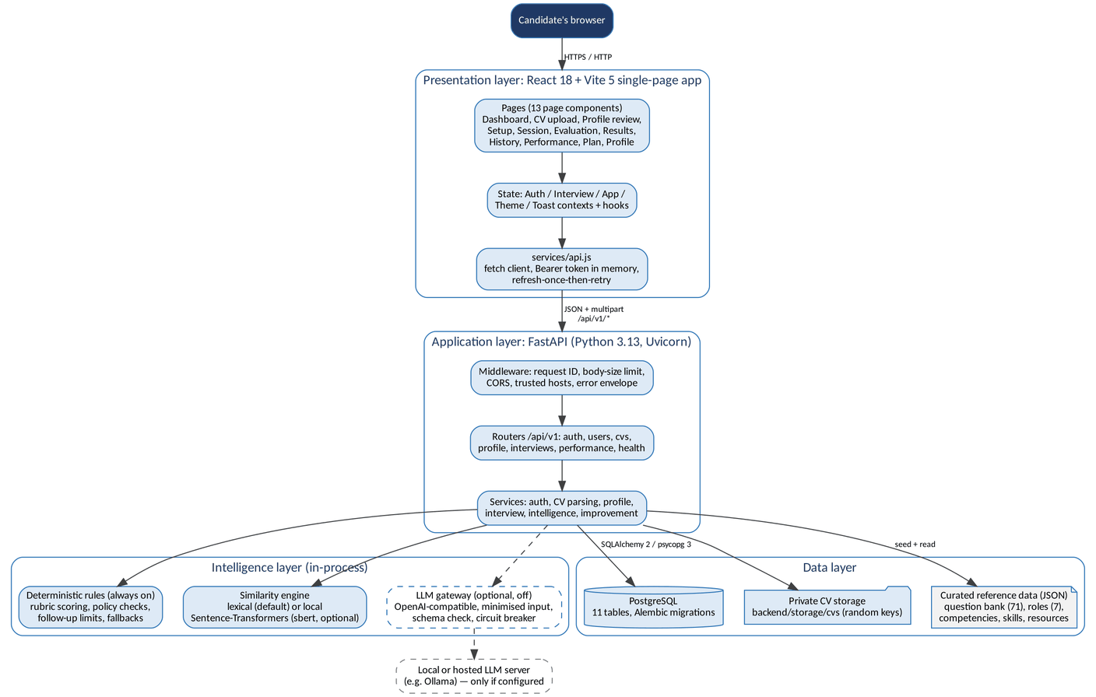
Figure 4.2 -- Layered architecture of the implemented system

4.4.2 Layers and Responsibilities
Layer | Location | Responsibilities
Presentation | src/ (React 18, Vite 5) | Screens, routing and guards, client state (contexts), animations, accessibility. services/api.js is the only place that talks to the API: it adds the access token, refreshes the session once on 401, maps responses to UI shapes and converts errors to readable messages.
API | backend/app/api | HTTP routes, request/response schemas (strict Pydantic models), authentication dependency (get_current_user), presenters that shape responses. No business logic.
Services | backend/app/services | Use-case logic: accounts and sessions, CV parsing and storage, profile, interview life cycle, question selection, intelligence context, improvement plans. Every query is filtered by the signed-in user.
Intelligence | backend/app/intelligence, scoring, llm | Profile extraction, competency model, semantic retrieval, rubric scoring and concept evidence, interview agent and policy, bounded LLM review, coaching rules, LLM gateway.
Data | backend/app/models, db, alembic, data/*.json | SQLAlchemy models, sessions, migrations, curated reference data (question bank, roles, competencies, skills, resources).
Cross-cutting | backend/app/core | Settings from environment, security (JWT, scrypt, cookies), rate limiting, error envelope, request IDs, trusted hosts, CORS, body-size limits.

4.4.3 Hybrid Intelligence Design
The intelligence layer follows a deterministic-first design. Rules always run and always decide; embeddings and an LLM can only add evidence or proposals that the rules validate. This keeps scoring explainable, repeatable and free of external dependencies, which the risk register requires for prompt injection (R10) and provider outages (R04).
Function | Always on (rules) | Optional: local embeddings | Optional: LLM (off by default)
Question planning | Role required/preferred skills, job-description skills, confirmed profile, difficulty, diversity, history penalty, coverage pass | Semantic similarity between the query and question documents | Not used
Answer evaluation | Six dimensions, concept statuses (demonstrated/partial/mentioned/missing), misconceptions, unsupported claims, evidence level | Concept matching and relevance | Bounded review: at most +/-15 points on key concepts and accuracy, only for concepts it can quote
Follow-ups (adaptive) | Agent actions continue / clarify / request_example / probe_concept / deepen with limits and policy | Not used | May propose an action; the policy accepts it or falls back to rules
Coaching | Plan v2: evidence groups, gaps need two weak answers, consistent strengths, competency table | Not used | Not used

4.4.4 Key Architectural Decisions
- Scoring only on the server. The frontend never sends scores that are trusted (test test_client_supplied_scores_are_ignored).
- Owner-scoped data access. Every service function receives the current user; foreign resources return 404.
- Reference answers are secret until evaluation, so the candidate cannot read the rubric before answering.
- Versioned scoring. Each evaluation stores scoring_version, model information and raw signals, so old results stay interpretable when the scorer changes.
- Single origin in production. The container serves the built SPA and the API from one address, so the refresh cookie stays first-party (SameSite=Strict) and no CORS is needed.
- Configuration through environment variables only; secrets are never stored in the repository.

4.5 Database Design
The database is PostgreSQL (decision D2), accessed with SQLAlchemy 2 and psycopg 3 and versioned with Alembic. It has 11 application tables plus Alembic's alembic_version. Results and performance statistics are not stored in separate tables: results are columns of the completed session and performance is computed from completed sessions, which avoids duplicated data (a deliberate change from the API specification's suggested interview_results and user_performance tables).

4.5.1 Entity Relationship Diagram
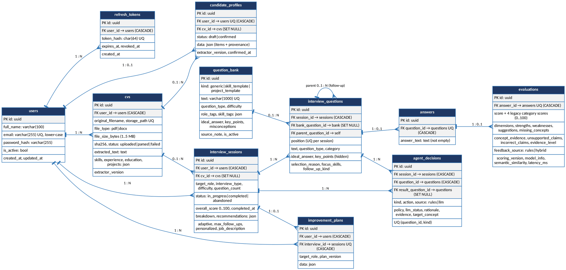
Figure 4.3 -- Entity relationship diagram (crow's foot; PK/FK rows shaded)

4.5.2 Logical Schema
Table 4.7 -- Tables and their purpose
Table | Purpose | Key relationships and rules
users | Account: full name, unique lower-cased email, scrypt hash, active flag. | Parent of all user data; deleting a user cascades.
refresh_tokens | Login sessions stored as SHA-256 hashes with expiry and revocation time. | Many per user.
cvs | CV metadata, random storage key (never returned), extracted text, skills and profile lines, status. | Many per user; sessions keep their history if a CV is deleted (SET NULL).
candidate_profiles | One structured profile per user (JSON items with provenance), draft or confirmed. | Unique per user; references the source CV.
question_bank | 71 curated questions (65 generic, 4 skill templates, 2 project templates), reference answers, key points, misconceptions, role and skill tags. | Shared reference data, not user data.
interview_sessions | One interview: role, type, difficulty, count, adaptive settings, job description, status, overall score and stored result summary. | Many per user; CHECK keeps completed_at consistent with status.
interview_questions | Questions asked, with a hidden snapshot of the reference answer and key points, selection reason, focus skills, follow-up parent. | Unique position per session; follow-ups reference their parent.
answers | The candidate's answer text. | At most one per question.
evaluations | Score, dimensions, strengths, weaknesses, suggestions, concept evidence, claims, evidence level, provenance (source, scoring version, model info, latency). | At most one per answer.
improvement_plans | Stored coaching plan (JSON) for a completed interview. | One per interview.
agent_decisions | Audit trail of the interview agent: action, source (rules or llm), policy result, rationale, evidence, target concept. | One per question and kind.

4.5.3 Physical Schema
- Keys: UUID primary keys on every table (generated in the application); created_at and updated_at timestamps with time zone.
- Types: varchar with explicit lengths for names and labels, text for free text, smallint for scores, numeric(5,4) for similarity, JSON for lists and structured documents (portable JSON type, JSONB on PostgreSQL).
- Enumerations (file type, CV status, question type, interview type, difficulty, session status, question kind, profile status) are stored as strings with CHECK constraints, so invalid values are rejected by the database as well as the ORM.
- Integrity: CHECK constraints for score ranges (0-100), positive question count and position, file size (1 byte to 5 MB), non-empty answers and lower-case email; unique constraints for email, storage path, token hash, question text, (session, position), one answer per question, one evaluation per answer.
- Delete rules: user data cascades from users; references to CVs and bank questions use SET NULL so history survives; follow-ups cascade with their parent question.
- Indexes: every foreign-key column is indexed (test test_every_foreign_key_column_is_indexed), plus composite indexes (user_id, created_at) and (user_id, status, completed_at) for history and statistics.

Normalisation
Core entities are in third normal form: every non-key column depends only on its table's key, and repeated data lives in its own table (users, CVs, sessions, questions, answers, evaluations). Three deliberate exceptions keep reads simple and history stable: (1) interview_questions stores a snapshot of the bank question's reference answer and key points, so editing the bank never changes past evaluations; (2) document-shaped data that is always read and written as a whole (candidate profile, improvement plan, evaluation dimensions and evidence) is stored as JSON; (3) the completed session stores its overall score and breakdown, which are derived values but are frozen at completion so later scoring changes do not rewrite results. No table stores data that can be recomputed on every request (performance statistics are computed).
Table 4.8 -- Migration history (backend/alembic/versions)
Revision | Date | Milestone | Change
9c35bf359c62 | 22 Oct 2026 | IM-2 | Initial schema: users, cvs, question_bank, interview_sessions, interview_questions, answers, evaluations.
285a552def9d | 22 Oct 2026 | IM-3 | Authentication (refresh_tokens, password hash), CV extraction fields, question-bank tags.
d87ec07e6d71 | 23 Oct 2026 | IM-4 | candidate_profiles, improvement_plans, evaluation dimensions, adaptive interview columns, question kind CHECK update.
ecf75151dd51 | 23 Oct 2026 | IM-5 | agent_decisions; evaluation evidence columns (concept_evidence, unsupported_claims, incorrect_claims, evidence_level).

Every migration has a tested downgrade path and an upgrade test that keeps existing data (test_migration_*_postgres.py). A test fails if a model change is made without a migration (test_models_and_migrations_are_in_sync).

4.6 Data Flow Diagrams

4.6.1 Context Diagram (Level 0)
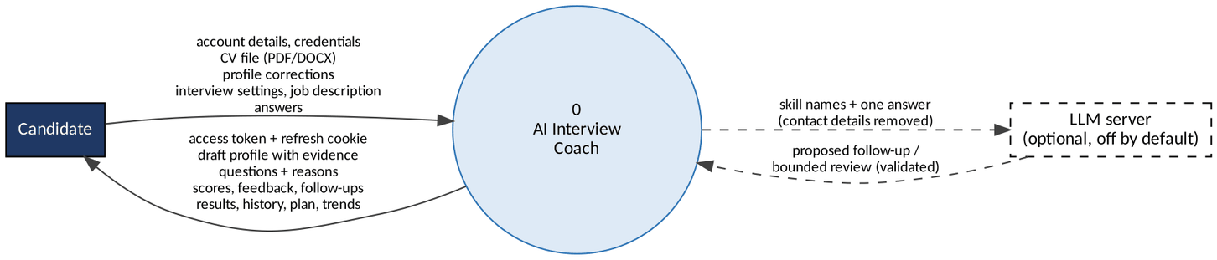
Figure 4.4 -- Context data flow diagram
The only external entities are the candidate and, when explicitly configured, an LLM server. The LLM receives skill names and one answer with contact details removed; it never receives the CV.

4.6.2 Level 1 Diagram
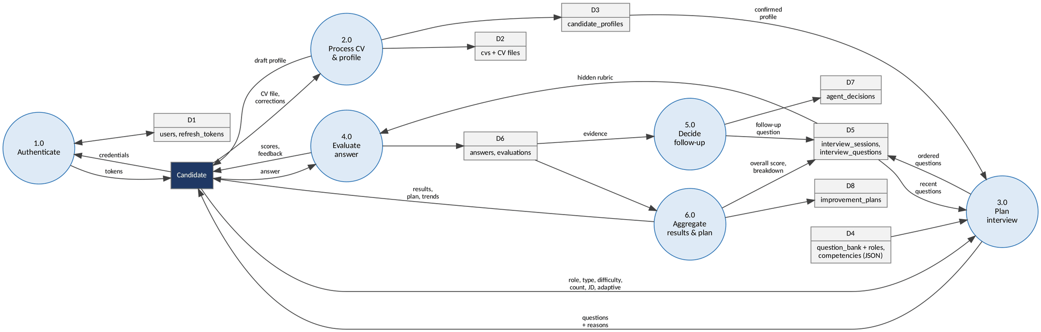
Figure 4.5 -- Level 1 data flow diagram
Process | Description | Main code
1.0 Authenticate | Register, log in, refresh (rotation with reuse detection), log out. | auth_service, core/security
2.0 Process CV and profile | Validate and store the file, extract text, build a draft profile with provenance, accept corrections. | cv_parsing, profile_extraction, profile_service
3.0 Plan interview | Rank bank questions using role, job description, confirmed profile, history and similarity; fill templates; store questions with reasons. | question_selection, retrieval
4.0 Evaluate answer | Score six dimensions, record concept evidence and claims, produce feedback; optional bounded LLM review. | scoring/*, evaluation_review
5.0 Decide follow-up | Agent proposes an action; policy validates it; decision and follow-up stored. | intelligence/agent, intelligence_service
6.0 Aggregate results and plan | Compute overall score and breakdown, recommendations, improvement plan, statistics and trend. | interview_service, improvement_service

4.7 Sequence Diagrams

4.7.1 Login and Session Refresh
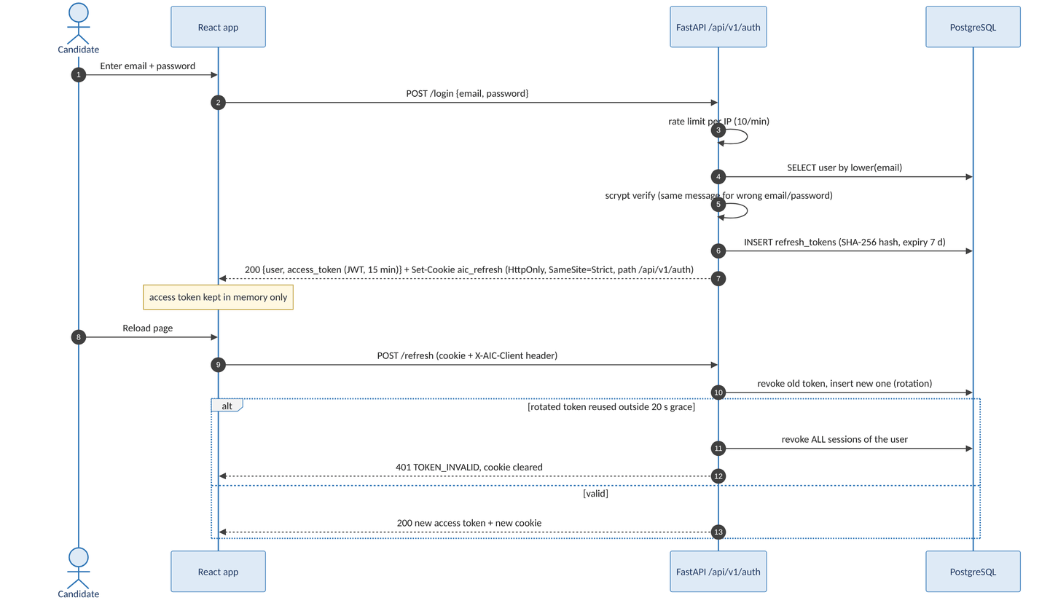
Figure 4.6 -- Login and refresh-token rotation

4.7.2 Answer Submission, Evaluation and Follow-up
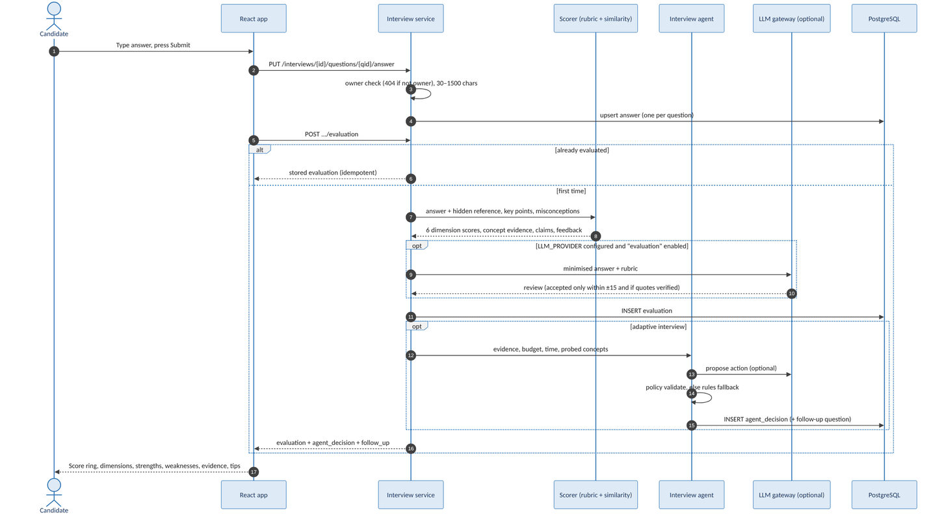
Figure 4.7 -- Answer, evaluation and adaptive follow-up

4.8 Activity Diagram
The interview workflow is shown in two parts: preparation (A) and the interview loop (B).
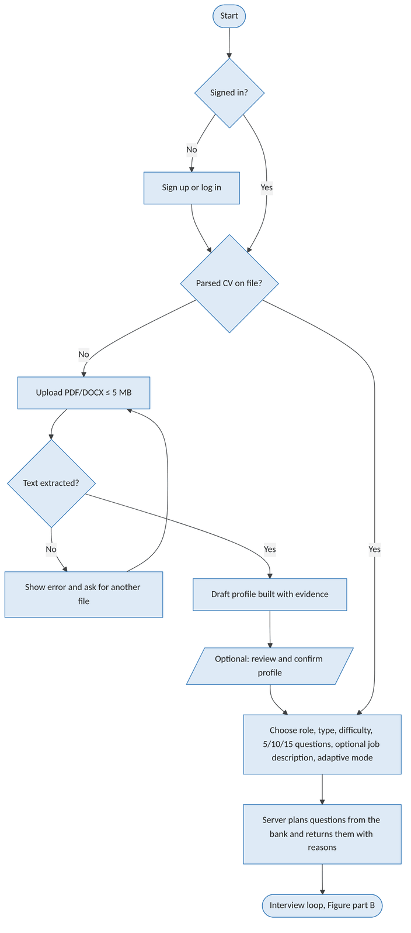
Figure 4.8 -- Activity diagram, part A: preparation
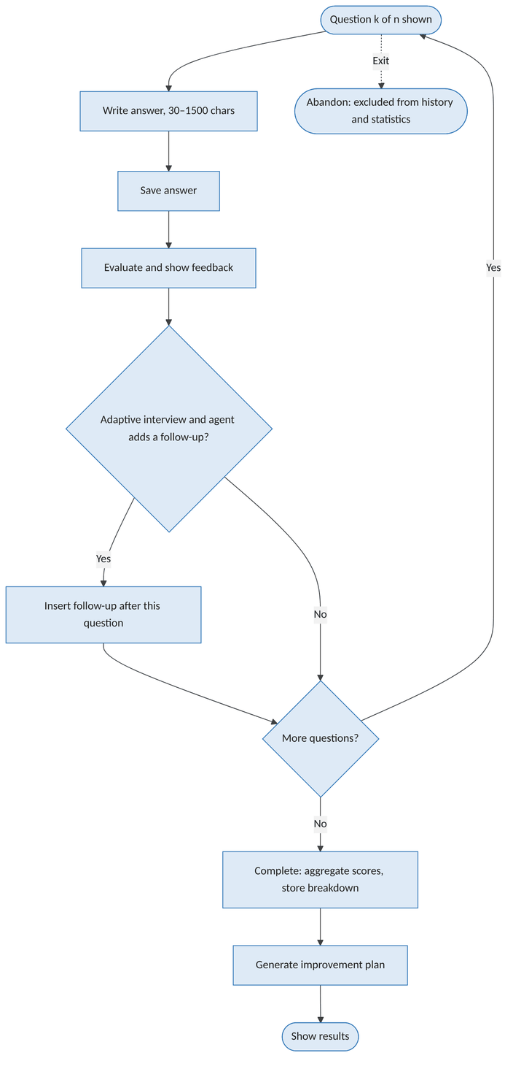
Figure 4.9 -- Activity diagram, part B: interview loop

4.9 State Diagrams
Three entities have an explicit life cycle. While an interview is in_progress, answers, evaluations and follow-ups are added; answers are locked once evaluated. Completed and abandoned interviews cannot change state again (test test_completed_interview_cannot_be_abandoned).
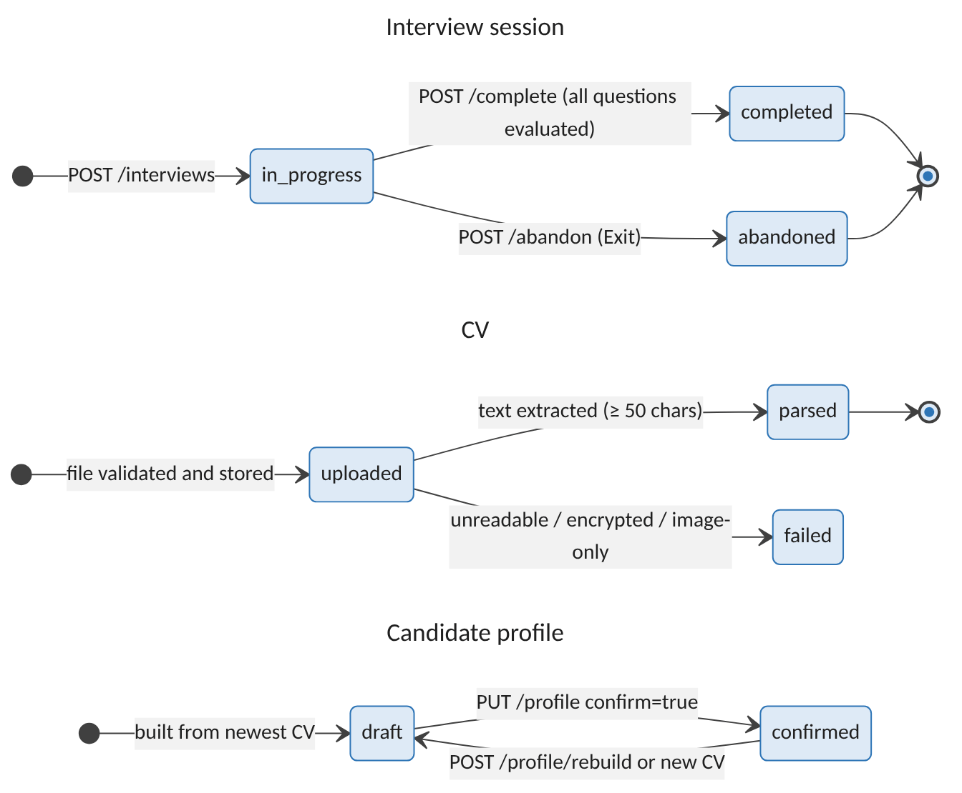
Figure 4.10 -- State diagrams: interview session, CV and candidate profile

4.10 Class Diagram
Figure 4.11 shows the domain classes (SQLAlchemy models) with their main attributes and the principal service modules. Services are Python modules of functions rather than classes; they are shown with the <<module>> stereotype.
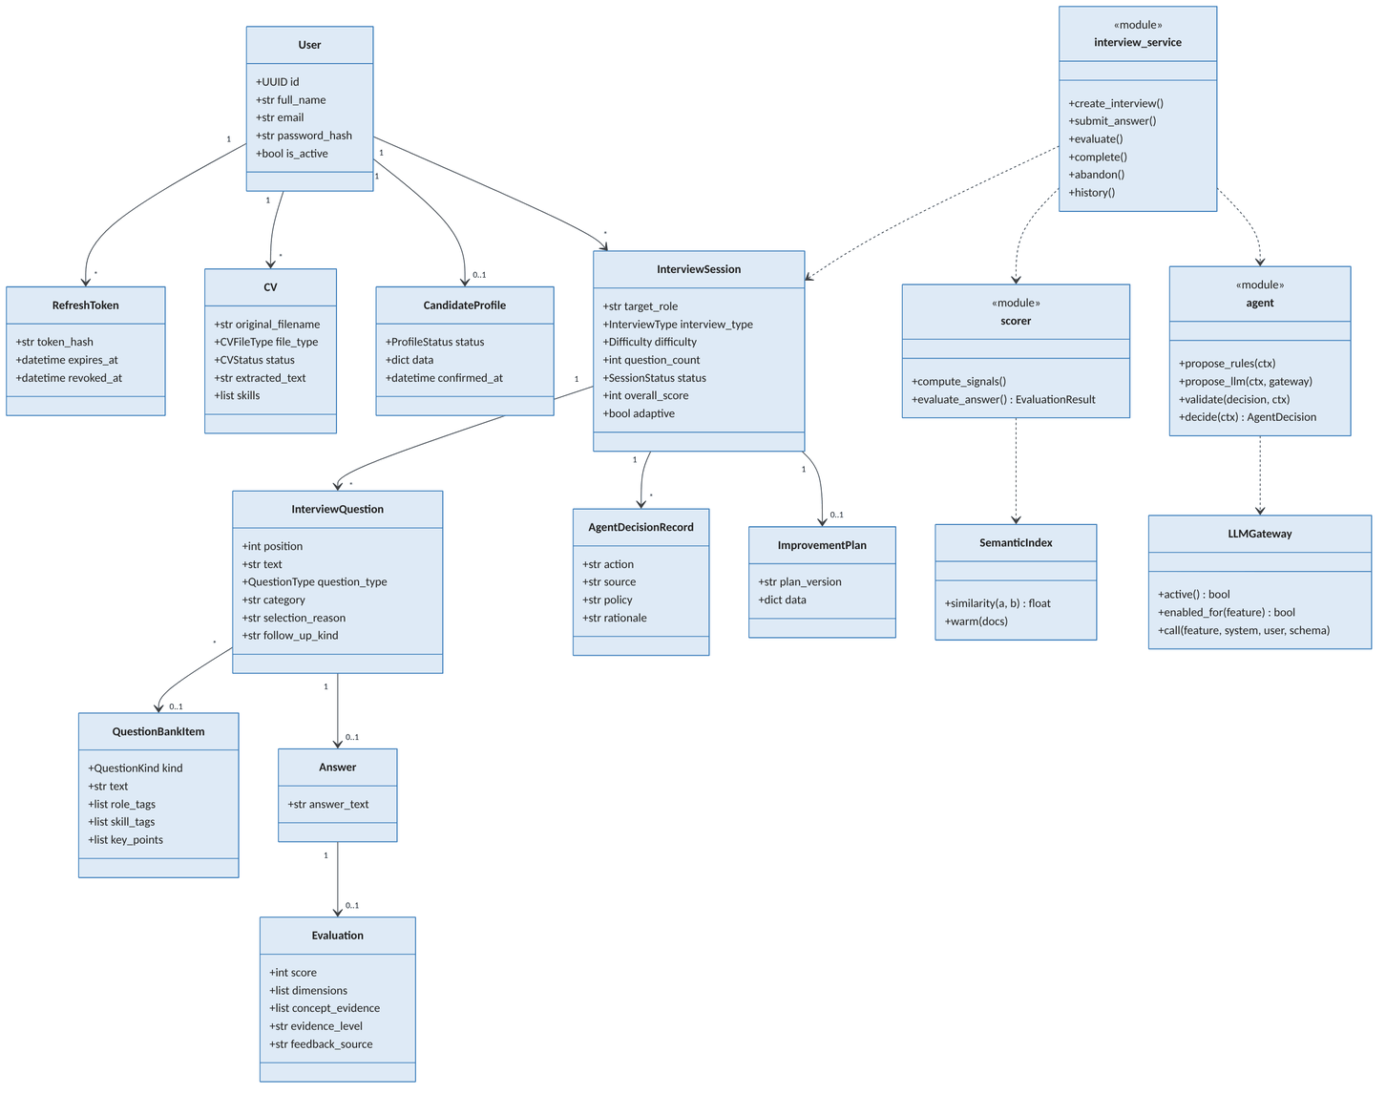
Figure 4.11 -- Class diagram (domain model and main services)

4.11 User Interface Design

4.11.1 Screens and Navigation
No Figma wireframes exist in the project files, so the mock-ups below are screenshots of the implemented application. Most were captured during the automated browser runs with synthetic test accounts (no real CV data); figures marked sample data were rendered from the current frontend build with invented example records. They replace wireframes as the reference for the UI.
Route | Screen | Purpose
/ | Landing | Product explanation and calls to sign up or log in.
/signup, /login | Authentication | Forms with inline validation; redirect if already signed in.
/dashboard | Dashboard | Average score, completed interviews, strongest and weakest area, recent sessions, skill snapshot.
/cv-upload | CV upload | Drag-and-drop upload, replace, remove, link to profile review.
/profile/review | Profile review | Draft or confirmed profile with provenance chips and evidence; edit and confirm.
/interview/setup | Interview setup | Role, type, difficulty, question count, job description, adaptive follow-ups; shows which intelligence is active.
/interview/session | Interview session | Question k of n, reason for the question, answer box with character count.
/interview/evaluation | Evaluation | Score ring, six dimensions, strengths, weaknesses, evidence, tips, agent decision, stronger answer.
/results | Results | Overall score, breakdown, recommendations, question-by-question dialog.
/history, /performance | History, Performance | Completed interviews; trend chart, skills and insight.
/plan, /plan/:id | Improvement plan | Strengths, gaps, competency table, practice, resources, next steps.
/profile | Profile and settings | Name, email, delete practice data.

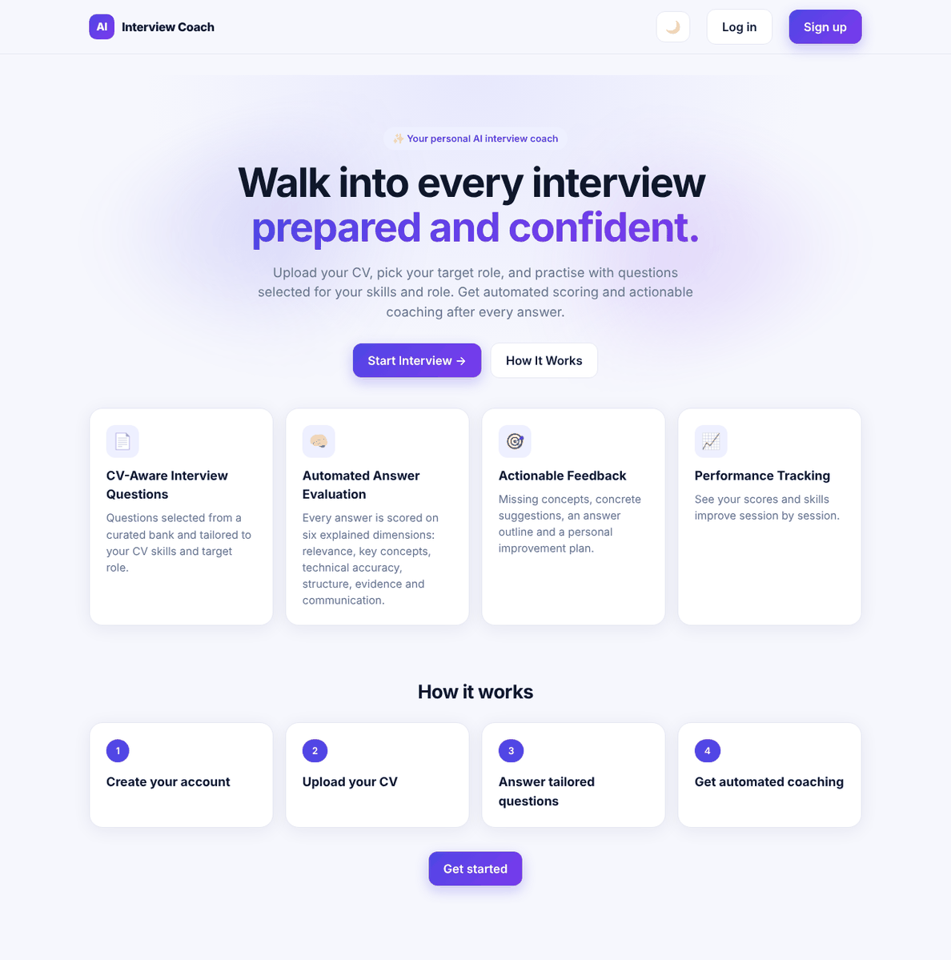
Figure 4.12 -- Landing page
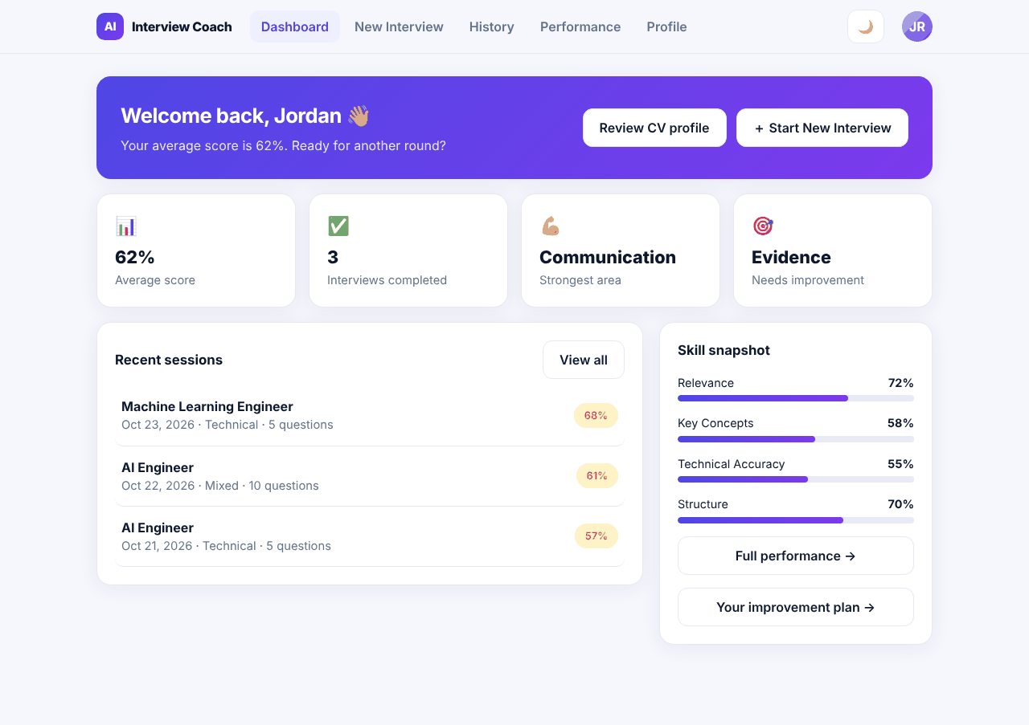
Figure 4.13 -- Dashboard (sample data)
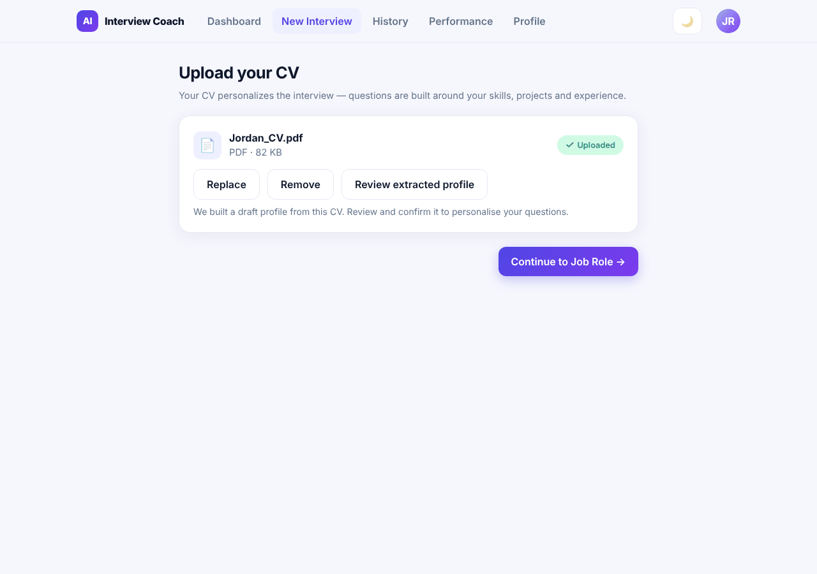
Figure 4.14 -- CV upload after a successful upload (sample data)
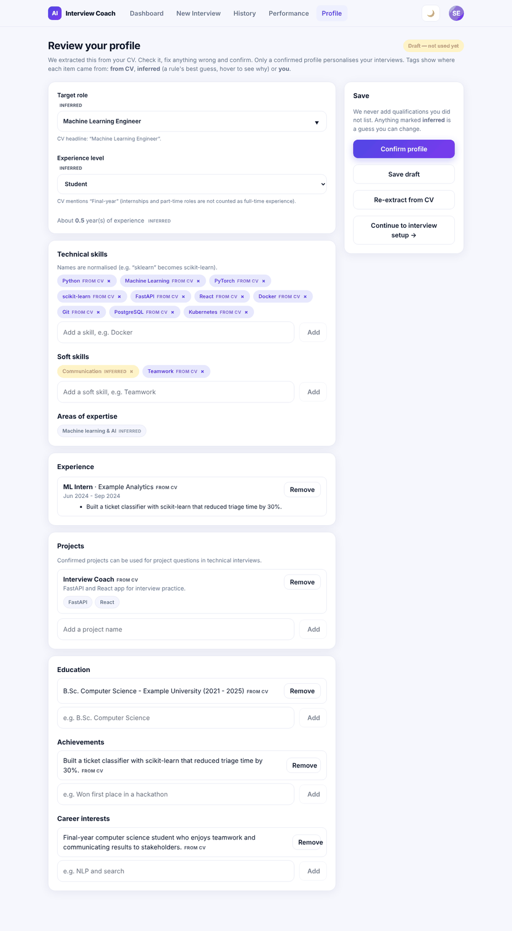
Figure 4.15 -- Profile review (draft profile with provenance)
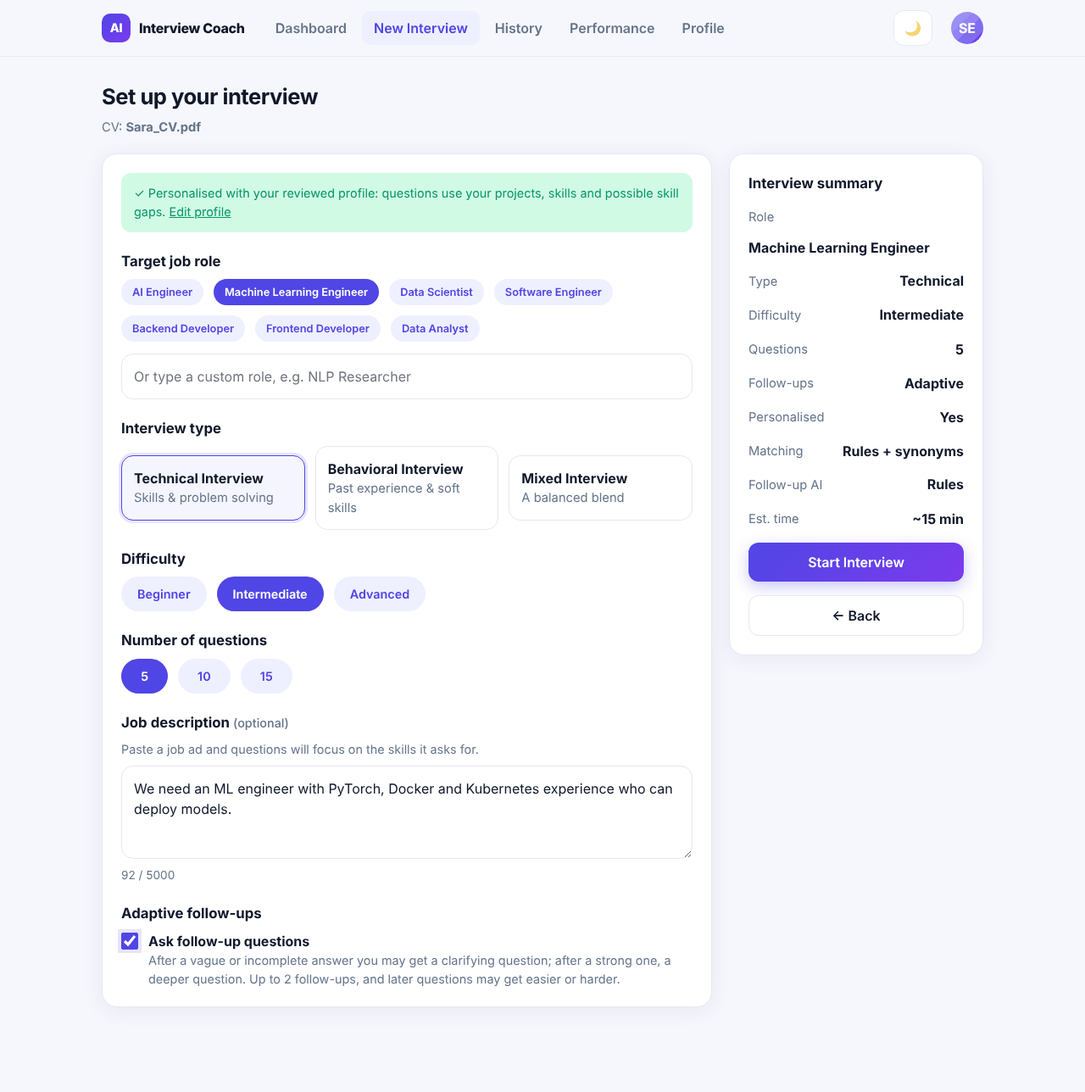
Figure 4.16 -- Interview setup
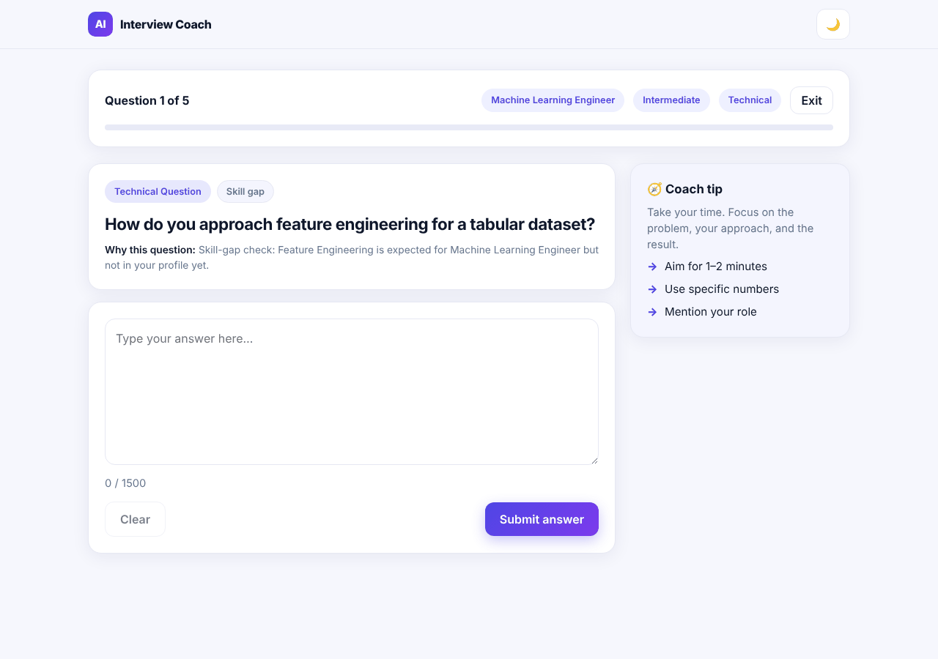
Figure 4.17 -- Interview session with the reason for the question
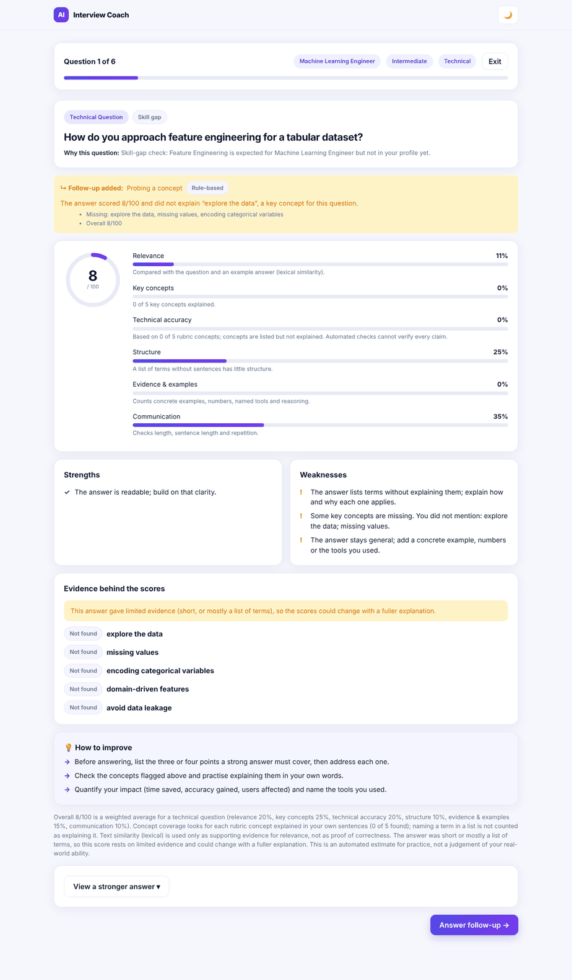
Figure 4.18 -- Evaluation feedback with an agent follow-up decision
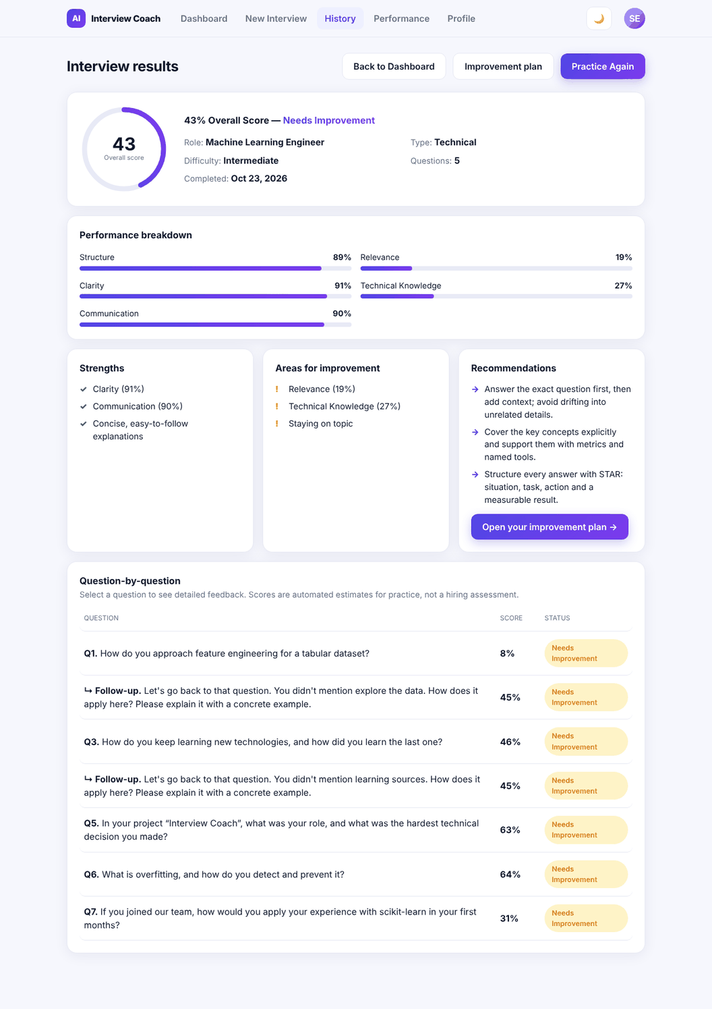
Figure 4.19 -- Interview results
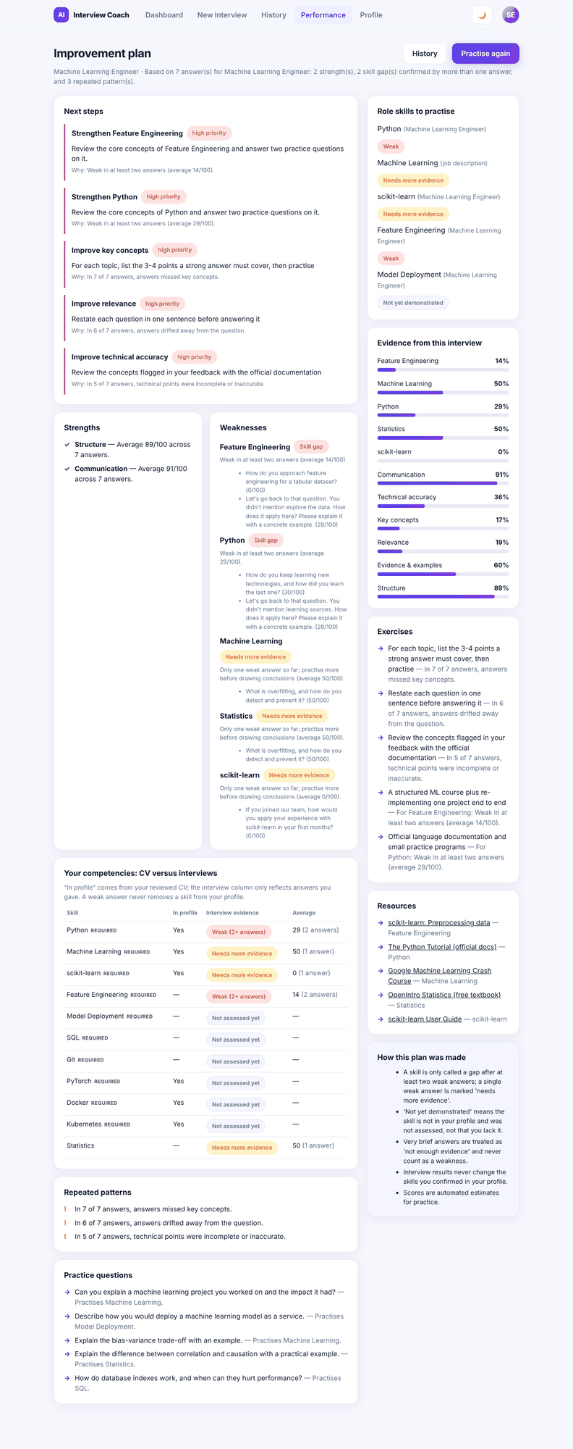
Figure 4.20 -- Improvement plan
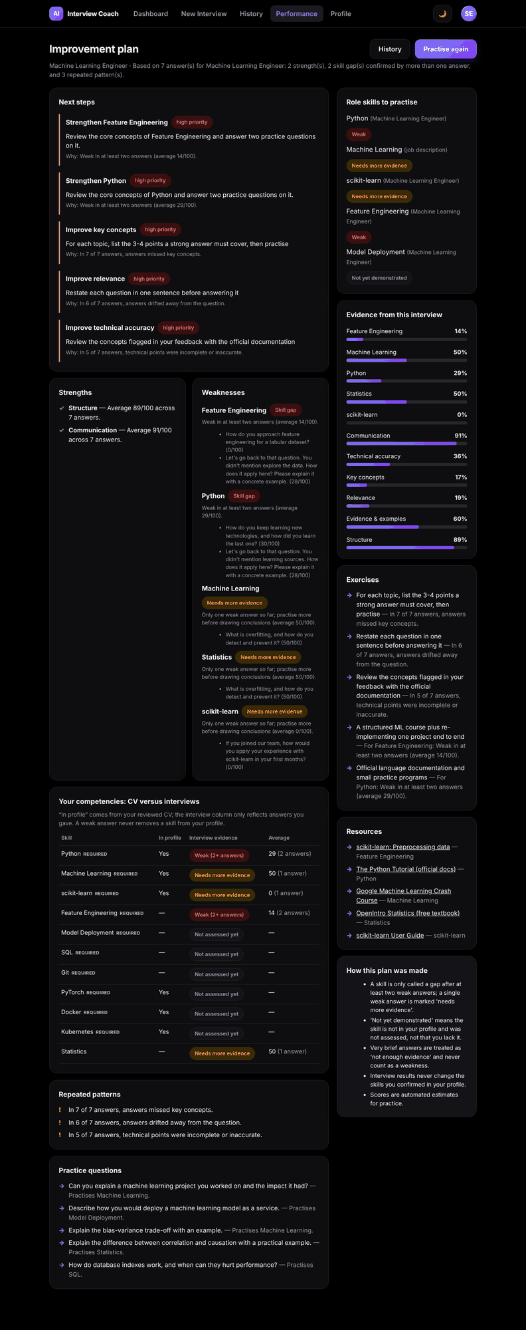
Figure 4.21 -- Improvement plan in dark theme
Figure 4.22 -- Improvement plan at phone width (390 px)
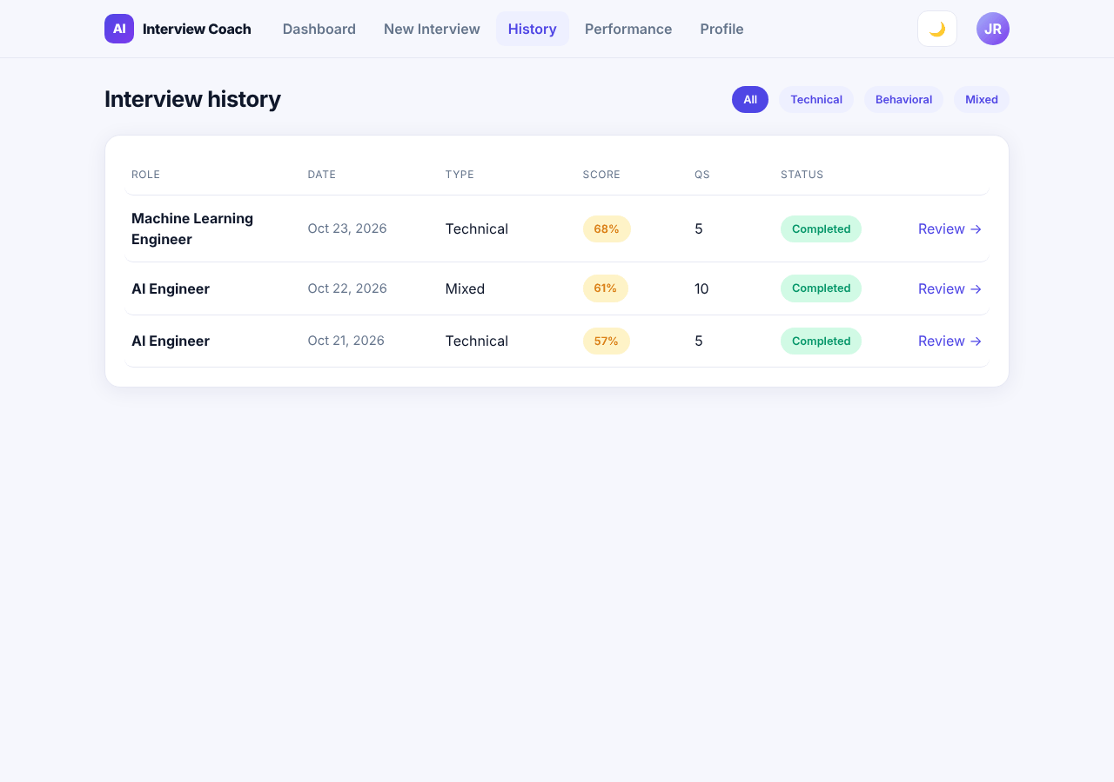
Figure 4.23 -- Interview history (sample data)
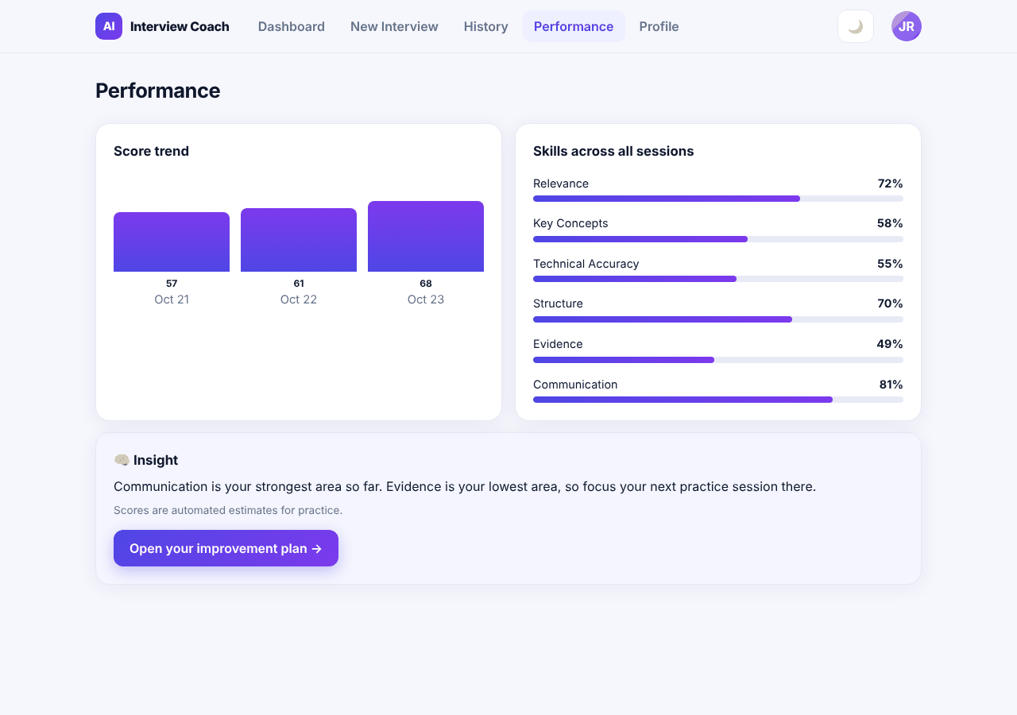
Figure 4.24 -- Performance (sample data)

4.11.2 UI/UX Guidelines
These guidelines are derived from the implemented design system (src/styles/variables.css, globals.css, animations.css and the shared components) and should be followed by any new screen.
Table 4.9 -- Design tokens (light / dark theme)
Token | Light | Dark | Use
--pri / --pri2 | #4F46E5 / #7C3AED | #818CF8 | Primary actions, active navigation, gradients (--grad).
--ink / --mut | #0F172A / #64748B | #F1F1F4 / #9A9AA5 | Body text / secondary text.
--bg / --card | #F6F7FD / #FFFFFF | #000000 / #0E0E10 | Page background / cards.
--line | #E6E8F3 | #232327 | Borders and dividers.
--ok / --warn / --bad | #059669 / #D97706 / #DC2626 | #34D399 / #FBBF24 / #F87171 | Success, warning and error states with matching light backgrounds (--okbg, --warnbg, --badbg).
--focus-ring | rgba(79,70,229,.14) | rgba(129,140,248,.2) | Visible keyboard focus.
--ease | cubic-bezier(.22,1,.36,1) | same | All transitions.

- Typography: Inter, then the system UI font stack. One H2 per page, H3 for cards; body text at the default size; secondary text uses --mut.
- Layout: centred content column, cards with 1 px --line border and soft shadow (--sh); two-column layouts collapse at 860 px and 760 px; phone layout uses a bottom tab bar (MobileTabBar).
- Components: reuse the 32 shared components (Button, Card, Chip, Modal, ConfirmModal, Toast, ScoreCircle, ProgressBar, Skeleton, DropZone, QuestionCard, Feedback, ConceptEvidence, AgentDecision, TrendChart and others) instead of new markup.
- Scores: always show the number and a text label (Excellent >= 88, Strong >= 78, Needs Improvement); never rely on colour alone. Explain every score in one sentence and call it an automated estimate for practice.
- Wording: say score, not confidence; say selected for you rather than generated; a single weak answer is "needs more evidence", not a weakness.
- Feedback states: skeletons while loading, a thinking indicator during evaluation, toasts and aria-live messages for results, inline messages for errors that say how to fix the problem.
- Destructive actions (delete data, exit interview) always use a confirmation dialog.
- Accessibility: labelled controls, keyboard-operable rows and menus, focus trap in dialogs, skip link, visible focus ring, reduced motion honoured (prefers-reduced-motion). Colour contrast has not been formally audited.
- Theme: light by default; dark theme via data-theme="dark", remembered per browser; every new colour must be defined for both themes.

4.12 Technology Stack
Table 4.10 -- Technology stack as implemented
Layer | Technology (version range) | Purpose
Frontend | React 18.3, React Router 6.30, Framer Motion 13.5, Vite 5.4, plain CSS with design tokens | Single-page application, routing, animation, build and dev server with API proxy.
Backend | Python 3.12+ (developed on 3.13), FastAPI (>= 0.115, < 1.0), Uvicorn | REST API and ASGI server; OpenAPI documentation at /docs.
Validation / config | Pydantic 2, pydantic-settings | Strict request schemas; settings from environment and backend/.env.
Database | PostgreSQL 16+ (developed on 18 locally), SQLAlchemy 2.x, Alembic, psycopg 3 (binary) | Persistence, ORM, migrations.
Security | PyJWT (HS256), scrypt (Python standard library), HttpOnly cookies | Access tokens, password hashing, refresh sessions.
CV parsing | pypdf; standard-library zip/XML for DOCX; python-multipart | Text extraction from uploads.
NLP / similarity | Built-in lexical engine (stems, concept synonyms, skill aliases); optional sentence-transformers all-MiniLM-L6-v2 (requirements-ml.txt) | Retrieval and concept matching; no external service.
Optional LLM | Any OpenAI-compatible chat-completions server (for example Ollama locally) via the standard library HTTP client | Follow-up proposals and bounded evaluation review; off by default.
Testing | pytest, Starlette TestClient with httpx2, Playwright (browser checks) | Unit, API, migration and end-to-end tests.
Packaging | Docker multi-stage image (node:20-slim build, python:3.13-slim runtime) | One container serving SPA and API.
Version control | Git and GitHub | Source history and collaboration.

Table 4.11 -- Planned (Document 1, Table 1.1) versus implemented technology
Area | Planned | Implemented | Status
Answer evaluation | Sentence Transformers; BERT / DistilBERT | Rubric scorer + lexical or local Sentence Transformers; no BERT/DistilBERT | Implemented (changed)
Generative AI | OpenAI API or Amazon Bedrock with RAG | Curated bank, retrieval and ranking; optional OpenAI-compatible LLM, off by default | Implemented (changed)
Vector store | pgvector / ChromaDB / FAISS (open) | None: bank documents embedded in memory with a disk cache | Implemented (changed)
Speech | Whisper (stretch) | Not built | Not implemented
Database | PostgreSQL / MySQL on AWS RDS | PostgreSQL (local; managed PostgreSQL for deployment) | Implemented (changed)
File storage | AWS S3 | Private local folder behind a storage abstraction | Implemented (changed)
Infrastructure | EC2, API Gateway, CloudWatch, GitHub Actions | Docker image; Azure Container Apps guide; no monitoring | Partially implemented

4.13 Component and Deployment Diagrams
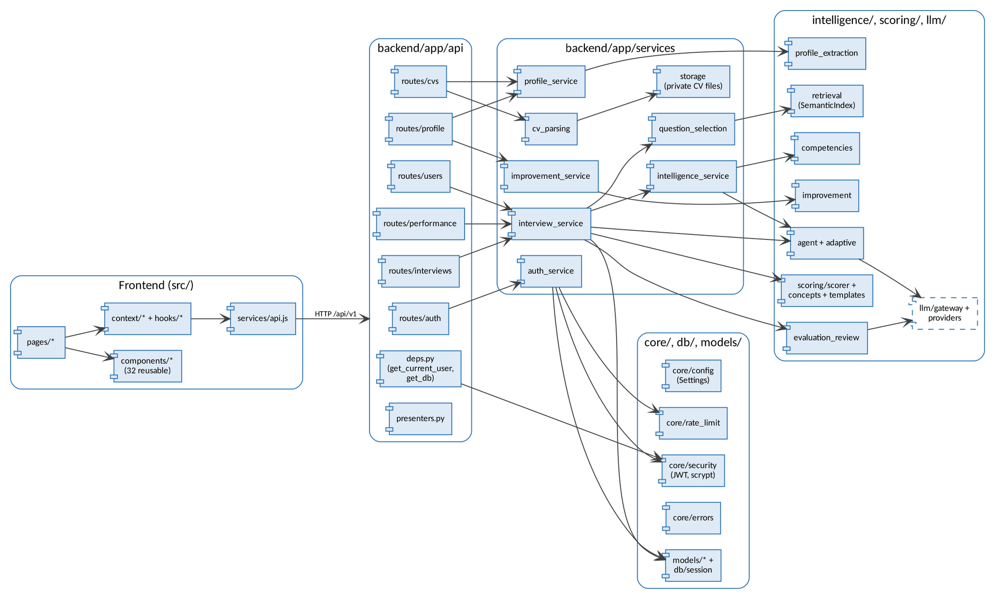
Figure 4.25 -- Component diagram (frontend and backend modules)

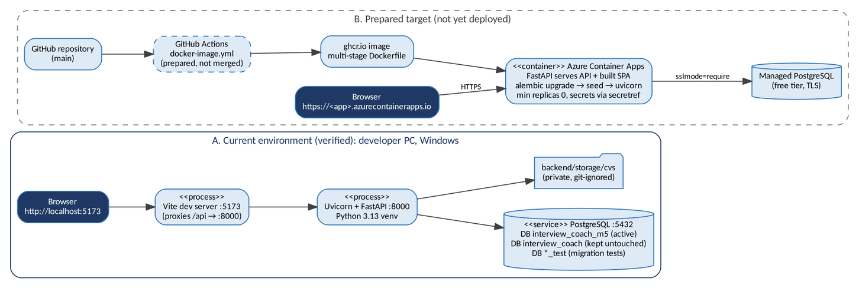
Figure 4.26 -- Deployment diagram: current local environment (A) and prepared target (B)
Environment A is the verified development setup. Environment B is prepared (Dockerfile in main; image workflow and Azure guide ready) but has not been deployed; see section 4.16 and Document 5, section 5.10.

4.14 API Documentation

4.14.1 Conventions
- Base path /api/v1; JSON bodies except CV upload (multipart/form-data, field file). Interactive OpenAPI documentation is served at /docs and /openapi.json.
- Authentication: Authorization: Bearer <access token> on every endpoint except register, login, refresh and health. Refresh and logout also require the header X-AIC-Client and the aic_refresh cookie.
- Errors always use one envelope: {"error": {"code", "message", "details", "retryable", "request_id"}}. Every response carries X-Request-ID.
- Another user's resource returns 404, never 403. Unknown request fields are rejected (422). JSON bodies are limited to 1 MB, CV uploads to 5 MB.
- Endpoint identifiers E01-E22 are those of API_SPECIFICATION.md. E23 (demo reset) was replaced by E24. E24-E29 are assigned here (Recommendation (review)) for endpoints added in implementation milestones IM-3 to IM-5.

4.14.2 Endpoint Catalogue
Table 4.12 -- Implemented endpoints (all under /api/v1 unless stated)
ID | Method and path | Purpose | Auth
E01 | POST /auth/register | Create account; returns user + access token, sets refresh cookie (201). | No
E02 | POST /auth/login | Log in (rate limited per IP). | No
E03 | POST /auth/refresh | Rotate refresh cookie, return new access token. | Cookie
E04 | POST /auth/logout | Revoke refresh token, clear cookie (204). | Cookie
E05 / E06 | GET, PATCH /users/me | Current user / update name or email. | Yes
E24 | DELETE /users/me/data | Delete my CVs, files, profile, interviews and plans (replaces E23). | Yes
E07 | POST /cvs | Upload and parse a CV; builds the draft profile (201). | Yes
E08 | GET /cvs | My CVs, newest first (paged). | Yes
E09 / E10 | GET, DELETE /cvs/{cv_id} | One CV with extracted data / delete it and its file. | Yes
E25 / E26 | GET, PUT /profile | My candidate profile / save corrections (confirm: true confirms). | Yes
E27 | POST /profile/rebuild | Re-extract from the newest CV, keeping user-added items. | Yes
E11 | POST /interviews | Create an interview and plan its questions (201). | Yes
E19 | GET /interviews | Completed interviews (history), newest first; ?type= filter. | Yes
E12 | GET /interviews/{id} | Interview state, progress, current position (resume). | Yes
E13 | POST /interviews/{id}/abandon | Exit an interview. | Yes
E14 | POST /interviews/{id}/complete | Aggregate scores and return results (idempotent). | Yes
E15 | PUT /interviews/{id}/questions/{qid}/answer | Save or replace an answer (30-1,500 characters). | Yes
E16 / E17 | POST, GET /interviews/{id}/questions/{qid}/evaluation | Evaluate (idempotent) / fetch the evaluation. | Yes
E18 | GET /interviews/{id}/results | Full results of a completed interview. | Yes
E28 | GET /interviews/{id}/improvement-plan | Plan for one completed interview. | Yes
E29 | GET /improvement-plans/latest | Plan for the most recent completed interview. | Yes
E20 | GET /performance/skills | Skill scores across completed interviews. | Yes
E21 | GET /performance/summary | Dashboard numbers and score trend. | Yes
E22 | GET /health | Readiness, database and intelligence mode. | No
-- | GET /health, GET /health/db (no prefix) | Liveness without database / database check (503 if unreachable). | No

4.14.3 Example: Create an Interview (E11)
POST /api/v1/interviews
Authorization: Bearer eyJhbGciOi...
{ "cv_id": "6f1c...", "target_role": "Machine Learning Engineer", "interview_type": "technical",
"difficulty": "intermediate", "question_count": 5, "job_description": null, "adaptive": true }

201 Created
{ "id": "a41e...", "status": "in_progress",
"config": { "target_role": "Machine Learning Engineer", "question_count": 5, "adaptive": true,
"max_follow_ups": 2, "personalized": true, "has_job_description": false, ... },
"questions": [ { "id": "...", "position": 1, "type": "technical", "category": "skill_gap",
"text": "How do you approach feature engineering for a tabular dataset?",
"reason": "Skill-gap check: Feature Engineering is expected for ...", "focus_skills": [...] }, ... ],
"created_at": "2026-10-23T19:12:04Z" }

4.14.4 Example: Evaluate an Answer (E16)
POST /api/v1/interviews/{id}/questions/{qid}/evaluation -> 200 OK
{ "overall_score": 64, "category_scores": { "relevance": 80, "clarity": 72, "technical_depth": 55, "structure": 60 },
"dimensions": [ { "key": "relevance", "label": "Relevance", "score": 80, "weight": 0.2, "explanation": "..." }, ... ],
"strengths": [...], "weaknesses": [...], "suggestions": [...], "improvement_tip": "...",
"missing_concepts": ["avoid data leakage"], "ideal_answer": "...", "ideal_outline": [...],
"concept_evidence": [ { "concept": "missing values", "status": "demonstrated", "evidence": "I imputed ..." } ],
"evidence_level": "sufficient", "feedback_source": "rules", "scoring_version": "lexical-v2",
"agent_decision": { "action": "probe_concept", "source": "rules", "policy": "accepted", "rationale": "..." },
"follow_up": { "id": "...", "position": 2, "follow_up_kind": "clarify", "text": "..." } }
Values in the examples are illustrative; field names are those of the response schemas in backend/app/schemas.

4.14.5 Error Codes
HTTP | Codes
401 | UNAUTHORIZED, INVALID_CREDENTIALS, TOKEN_EXPIRED, TOKEN_INVALID
403 / 404 | FORBIDDEN (missing client header); NOT_FOUND, CV_NOT_FOUND, INTERVIEW_NOT_FOUND, QUESTION_NOT_FOUND, ANSWER_NOT_FOUND, EVALUATION_NOT_FOUND, PROFILE_NOT_FOUND, PLAN_NOT_FOUND
409 | EMAIL_ALREADY_REGISTERED, EMAIL_ALREADY_IN_USE, ANSWER_ALREADY_EVALUATED, INTERVIEW_NOT_ACTIVE, INTERVIEW_INCOMPLETE, RESULTS_NOT_AVAILABLE
413 / 415 | FILE_TOO_LARGE, PAYLOAD_TOO_LARGE / UNSUPPORTED_FILE_TYPE
422 | VALIDATION_ERROR, INVALID_INTERVIEW_CONFIG, CV_REQUIRED, CV_UNREADABLE, ANSWER_EMPTY, ANSWER_TOO_SHORT, ANSWER_TOO_LONG, QUESTION_BANK_INSUFFICIENT
429 / 5xx | RATE_LIMITED (with Retry-After); AI_SERVICE_UNAVAILABLE (503, embedding model failed to load), DATABASE_UNAVAILABLE, INTERNAL_ERROR

4.15 Testing and Validation Strategy
Testing is designed in layers so that each risk in Document 1, section 1.4 has a matching check. The full test plan, test cases, results and bug reports are in Document 6.
Level | What is validated | Tooling
Unit | Scoring rules, concept evidence, selection, agent policy, profile extraction, LLM gateway, configuration | pytest
API / integration | Every endpoint with an in-memory database: validation, errors, auth, ownership, idempotency | pytest + TestClient
Security / isolation | Cross-user access returns 404; token rotation and reuse; rate limits; unsafe production settings refused | pytest
Database / migration | Schema at head, model-migration sync, PostgreSQL types and constraints, upgrades keep data | pytest on a separate *_test PostgreSQL database
Model quality | Agreement with labelled answer cases (development and held-out), follow-up appropriateness, selection coverage and repeats, latency, memory | scripts/benchmark_intelligence.py
End-to-end | Real browser journeys for two users on the production build, including phone width and dark theme | Playwright scripts
Validation still open | Correlation of scores with human ratings (Document 1, KPI 6-7); usability study (NFR-050); load and availability tests | Planned (Document 6, 6.6)

4.16 Deployment Strategy

4.16.1 Environments
Environment | Purpose | Status
Development | Each developer: Vite dev server, Uvicorn with reload, local PostgreSQL (interview_coach_m5 active; the original interview_coach database is kept untouched). | Implemented
Test | In-memory SQLite for API tests; separate PostgreSQL database whose name must end in _test for migration tests. | Implemented
Production (target) | One container on Azure Container Apps (consumption plan, scale to zero) with a managed PostgreSQL database over TLS. | Prepared

4.16.2 Release Procedure (target)
- Merge to main after tests and the frontend build pass.
- GitHub Actions builds the multi-stage Docker image and publishes it to GitHub Container Registry.
- The container start command runs alembic upgrade head, seeds the question bank (idempotent) and starts Uvicorn on $PORT.
- Secrets (DATABASE_URL, JWT_SECRET) are stored as platform secrets; APP_ENV=production refuses to start with a weak secret, insecure cookies or a wildcard CORS origin.
- ALLOWED_HOSTS and CORS_ORIGINS are set to the public host name (the earlier "Invalid host header" failure on Hostless was caused by a missing ALLOWED_HOSTS entry).
- Check GET /api/v1/health, then run the manual smoke test (sign up, upload a test CV, complete one interview).
- Rollback: redeploy the previous image tag; database downgrades are available but should follow a pg_dump backup.
Detailed commands are in DEPLOY_AZURE.md and Document 5, section 5.10. AWS remains the long-term option from the proposal (D8) once access is confirmed.

Appendix A -- Consistency With Documents 1-3
Documents 1-3 are consolidated planning documents and remain valid as the record of what was planned and required. This appendix lists where the built system answers their open decisions or differs from them, so readers can move between the two sets without contradiction.
Item in Documents 1-3 | Resolution in the implementation | Reference
C-01 / IMP-01 Schedule baselines (14 weeks, 10 weeks, 6 phases) | Implementation followed five milestones IM-1 to IM-5 (Document 5, 5.1). The course schedule remains To Be Confirmed. | Doc 5
C-03 / IMP-03 Voice input | Not built in this release (D6). FR-035 to FR-038 remain open for a later release. | 4.3.1
C-04 / IMP-08 Database engine | PostgreSQL (D2). | 4.5
C-05 / IMP-09 Vector store | None needed for 71 questions; in-memory vectors with disk cache. | 4.12
C-07 / IMP-04, IMP-09 GenAI provider | No provider by default (D4); optional OpenAI-compatible endpoint, local first. | 4.4.3
C-08 Orchestration framework | None; plain Python modules. | 4.4
C-06 / IMP-05, IMP-10 Acceptance targets | Measured values are reported in Document 6 against each target; human-rated correlation not yet measured. | Doc 6
IMP-06 Requirement identifiers | Document 3 FR-001...FR-073 / NFR-001...NFR-073 are used in Documents 4-7. | 4.3
IMP-07 Authentication parameters | Access token 15 min, refresh 7 days with rotation, password >= 8 characters, 10 attempts per minute per IP. | Table 4.6
IMP-11 Alarm thresholds | No alarms implemented; still open for deployment. | Doc 6
Objectives O1-O6 | Status in Table 4.1. | 4.1.2
"Confidence score" wording | Renamed to score (D5). | FR-044
Project handbook: frontend in frontend/ folder | The frontend is at the repository root (src/, public/, index.html); the handbook was corrected. | Doc 5, 5.2

